Introduction to the global goals

Introduction
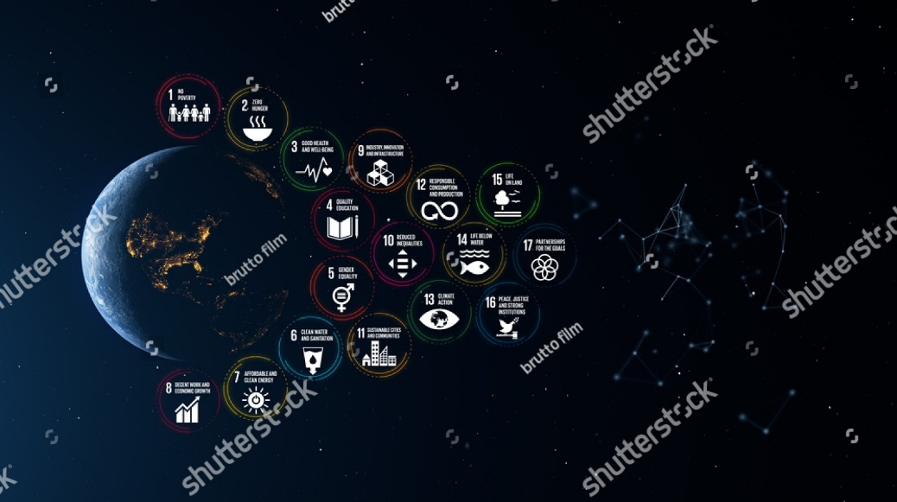
Tq-image-middle
URL | 1659400339 / brutto film / shutterstock.com

The idea of Sustainable Development Goals, also known as the global goals, was launched in 2012, on the 20th anniversary of the Rio Earth Summit in 1992. The Rio Earth Summit was the first time that world leaders got together to face the challenges of the relatively new concept of sustainable development.
The global goals build on the achievements of the Millennium Development Goals (MDGs), but they go even further and provide a framework that puts together the three basic pillars of sustainability: economic development, including ending poverty; social inclusion, gender equality, the rights of minority groups, reducing inequalities in society; and environmental sustainability. While the Millennium Development Goals (MDG) were directed to the world's poorest countries and the poorest people in middle-income countries, the global goals are universal. Universal means that every country globally, rich or poor, has a challenge of putting together society's economic, social, and environmental objectives.
The global goals offer a blueprint to achieve sustainable development in the coming generation.

Objectives
This module will introduce the global goals. At the end of the module, you should better understand how the Goals came into being and what each goal aims to achieve by 2030.

Tq-panel-video
‘We The People' for The Global Goals | Global Goals (2:58):

Millennium Development Goals
In September 2000, building upon a decade of major United Nations conferences and summits, world leaders came together at the United Nations Headquarters in New York to adopt the United Nations Millennium Declaration. All nations committed to a new global partnership to reduce extreme poverty and set out a series of time-bound targets. With a deadline of 2015 – the Millennium Development Goals (MDGs) started the global sustainable development journey.¹
The global mobilisation behind the Millennium Development Goals produced what is considered to be the most successful anti-poverty movement in history. The landmark commitment entered into by world leaders in the year 2000 — to ‘spare no effort to free our fellow men, women and children from the abject and dehumanising conditions of extreme poverty’. The commitment entered into by world leaders was translated into an inspiring framework of eight goals and, then, into wide-ranging practical steps that enabled people across the world to improve their lives and their prospects.
The Millennium Development Goals (MDG) helped lift more than one billion people out of extreme poverty, make inroads against hunger, enable more girls to attend school than ever before, and protect our planet. They generated new and innovative partnerships, galvanised public opinion and showed the immense value of setting ambitious goals. The Millennium Development Goals (MDG) reshaped decision-making in developed and developing countries alike by putting people and their immediate needs at the forefront. ²
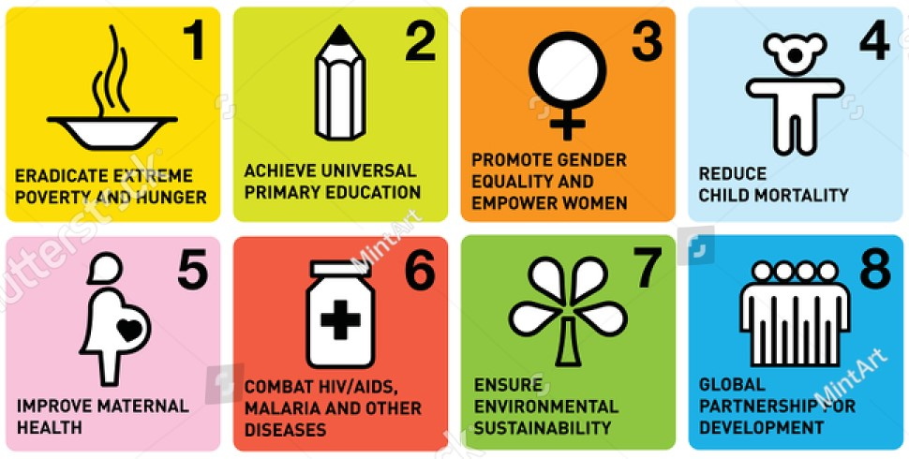
Eighteen targets underpinned the eight Millennium Development Goals (MDG). Interestingly, the eight goals and targets were not explicitly defined in the Millennium Declaration.
Tq-image-middle
URL | 1502526881 / MintArt / shutterstock.com

Tq-comment
MM – please link ‘A_RES_55_2_E.pdf’ and ‘Handout 7 - Millennium Development Goals.pdf’ located in the Files for MM folder to the link text in the Document panel below.

Tq-panel-document
- United Nations millennium declaration – 18 September 2000 (PDF 63 KB)
- Handout 7 - Millennium development goals (MDGs) (PDF 168 KB)

Achievements of the Millenium Development Goals (MDG)
At the end of the Millennium Development Goals (MDG) period in 2015, the world community has reason to celebrate. Thanks to concerted global, regional, national and local efforts, the Millennium Development Goals (MDG) had saved the lives of millions and improved conditions for many more. These efforts proved that, with targeted interventions, sound strategies, adequate resources and political will, even the poorest countries could make dramatic and unprecedented progress.
Although significant achievements were made on many of the eighteen Millennium Development Goals (MDG) targets worldwide, progress was uneven across regions and countries, leaving significant gaps. Millions of people are being left behind, especially the poorest and those disadvantaged, because of their sex, age, disability, ethnicity or geographic location. Targeted efforts will be needed to reach the most vulnerable people. At the end of the Millennium Development Goals (MDG) period, the remaining shortfalls included:
- Gender inequality persists
- Significant gaps exist between the poorest and wealthiest households and between rural and urban areas
- Climate change and environmental degradation undermine progress achieved, and poor people suffer the most
- Conflicts remain the biggest threat to human development
- Millions of poor people still live in poverty and hunger, without access to essential services ³

Tq-plugin-flipcards
Select each image below to reveal a summary of three-millennium development goals achieved.
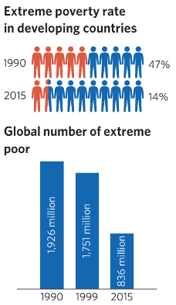  [Image] | Goal 1 - Eradicate extreme poverty and hunger  Extreme poverty declined significantly over the last two decades.  Globally, the number of people living in extreme poverty declined by more than half, falling from 1.9 billion in 1990 to 836 million in 2015. Most progress has occurred since 2000.  The proportion of undernourished people in developing regions fell from 23.3 per cent in 1990–1992 to 12.9 per cent in 2014–2016.
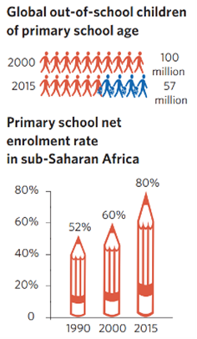  [Image] | Goal 2: Achieve universal primary education  The primary school net enrolment rate in the developing regions reached 91 per cent in 2015, up from 83 per cent in 2000.  The number of out-of-school children of primary school age worldwide fell by almost half, to an estimated 57 million in 2015, down from 100 million in 2000.  The literacy rate among youth aged 15 to 24 increased globally from 83 per cent to 91 per cent between 1990 and 2015. The gap between women and men narrowed.
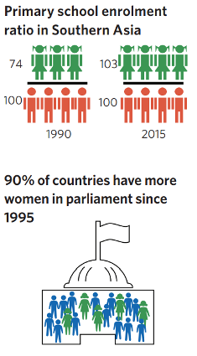  [Image] | Goal 3: Promote gender equality and empower women  In Southern Asia, only 74 girls were enrolled in primary school for every 100 boys in 1990. In 2015, 103 girls were enrolled for every 100 boys.  Women now made up 41 per cent of paid workers outside the agricultural sector, an increase from 35 per cent in 1990.  Between 1991 and 2015, the proportion of Women gained ground in parliamentary representation in nearly 90 per cent of the 174 countries with data over the previous 20 years. The average proportion of women in parliament almost doubled during the same period. Yet still, only one in five members were women in 2015.

Tq-panel-video
- Eight-millennium development goals: What we met and missed (2:01)
- Transitioning from the millennium development goals (MDG) to the sustainable development goals (SDP) (3:02).

Tq-comment
MM – please link ‘MDG 2015 rev (July 1).pdf’ located in the Files for MM folder to the link text in the Document panel below.
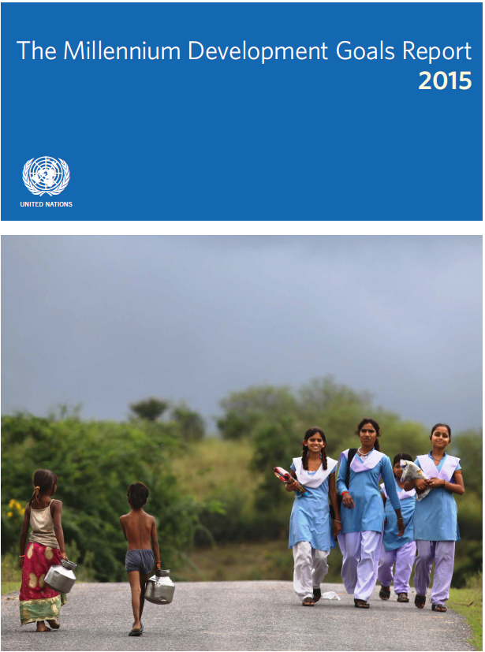
Tq-panel-document
- The Millennium Development Goals Report 2015 (PDF 6,958 KB)

Transforming our World

Tq-image-middle
URL | 1865955766 / MintBlac / shutterstock.com
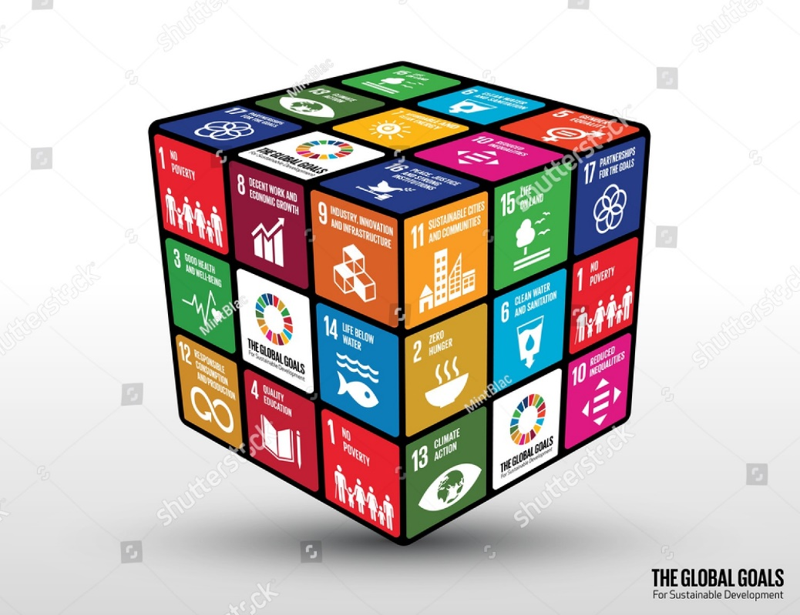

The seminal document for the global goals is the General Assembly Resolution 70/1 dated 25 September 2015 titled ‘Transforming our world: the 2030 Agenda for Sustainable Development’. ⁴
The preamble is explicit and ambitious language and leaves little doubt what the plan is aiming to achieve: This Agenda is a plan of action for people, planet and prosperity. It also seeks to strengthen universal peace in larger freedom. We recognise that eradicating poverty in all its forms and dimensions, including extreme poverty, is the greatest global challenge and an indispensable requirement for sustainable development.
After announcing what the Agenda aims to achieve, the resolution briefly describes the scope of the document: ‘All countries and all stakeholders, acting in collaborative partnership, will implement this plan. We are resolved to free the human race from the tyranny of poverty and want and to heal and secure our planet. We are determined to take the bold and transformative steps urgently needed to shift the world on a sustainable and resilient path. As we embark on this collective journey, we pledge that no one will be left behind.’
The resolution succinctly articulates what the representatives from 193 countries intend to achieve: ‘We resolve, between now and 2030, to end poverty and hunger everywhere; to combat inequalities within and among countries; to build peaceful, just and inclusive societies; to protect human rights and promote gender equality and the empowerment of women and girls, and to ensure the lasting protection of the planet and its natural resources. We also resolve to create conditions for sustainable, inclusive and sustained economic growth, shared prosperity and decent work for all, taking into account different levels of national development and capacities.’
The resolution then summarises the New Agenda: ‘17 Sustainable Development Goals with 169 associated targets which are integrated and indivisible. Never before have world leaders pledged common action and endeavour across such a broad and universal policy agenda. We are setting out together on the path towards sustainable development, devoting ourselves collectively to the pursuit of global development and of ‘win-win’ cooperation which can bring huge gains to all countries and all parts of the world.’
It is refreshing to note that the resolution goes further than just articulating the 17 goals and 169 targets – it also describes the ‘Means of implementation’ and the ‘Follow-up and review’. Before the document launches into the goals and targets, it outlines ‘A call for action to change our world’. The final paragraph summarises the situation in which the planet finds itself and doesn’t pull any punches: ‘The future of humanity and our planet lies in our hands. It also lies in the hands of today’s younger generation, who will pass the torch to future generations. We have mapped the road to sustainable development; it will be for all of us to ensure that the journey is successful and its gains irreversible.’
Every year, the United Nations publishes a comprehensive report on the latest data to track the global goals' progress (or otherwise). Five years into the year of the global goals, 2020 reports progress remains uneven, and the planet is not on track to meet the Goals by 2030.
Tq-comment
MM – please link ‘21252030 Agenda for Sustainable Development web.pdf’ and ‘The-Sustainable-Development-Goals-Report-2020.pdf’ located in the Files for MM folder to the link text in the Document panel below.

Tq-panel-document
- Transforming our World: The 2030 agenda for sustainable development
- The sustainable development goals report 2020

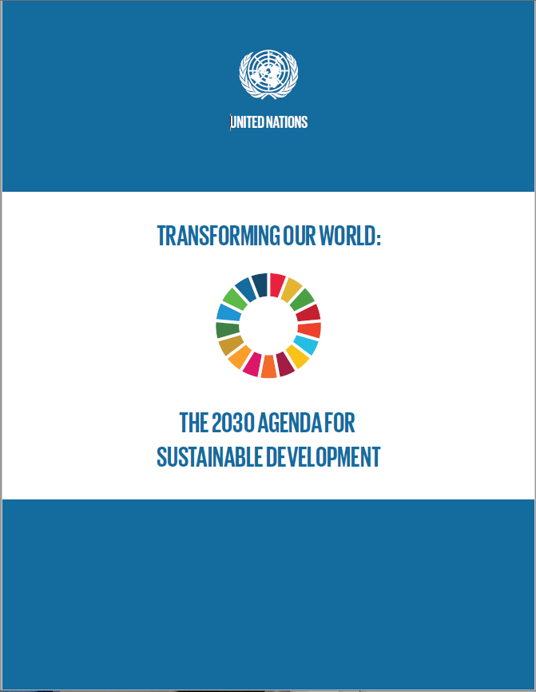 | 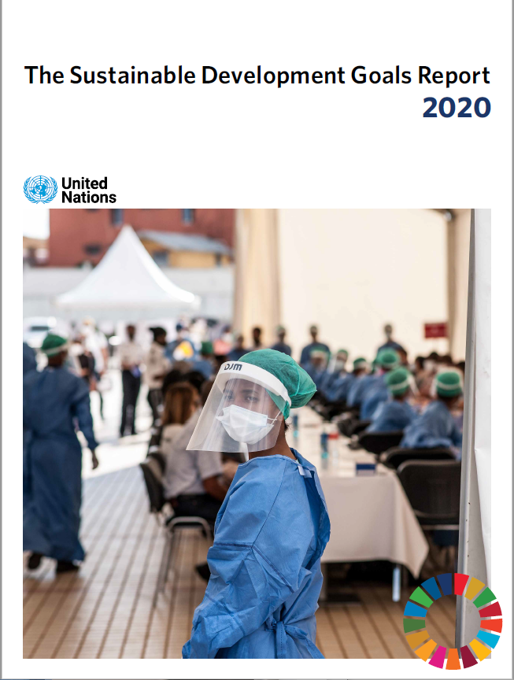

Leave No One Behind

Tq-image-middle
URL | 331225082 / Travel Stock / shutterstock.com

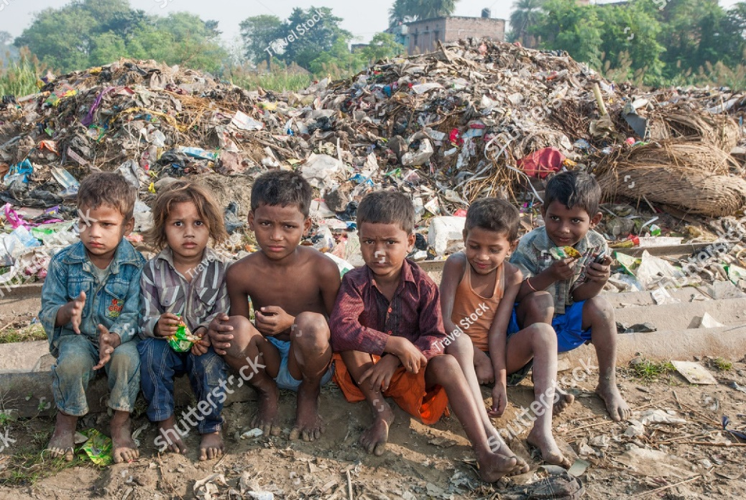
The 2030 Agenda commits to leaving no one behind – this is an ambitious but necessary compass for the sustainable development journey. The country representatives use the term ‘pledge’ to define their commitment to this caveat: ‘As we embark on this great collective journey, we pledge that no one will be left behind.’ The Agenda goes further and states that not only will no one be left behind, but the priority will be given to the furthest behind.
‘Recognising that the dignity of the human person is fundamental, we wish to see the Goals and targets met for all nations and peoples and all segments of society. And we will endeavour to reach the furthest behind first.’
The statement reminding us that no one will or must be left behind appears four times throughout the document. In addition to the first pledge, the resolution states that ‘To promote physical and mental health and well-being, and to extend life expectancy for all, we must achieve universal health coverage and access to quality health care. No one must be left behind.’ When describing the data required to support the goals and targets, the document states: ‘Indicators are being developed to assist this work. Quality, accessible, timely and reliable disaggregated data will be needed to help with the measurement of progress and to ensure that no one is left behind.’
Finally, there is a statement in the ‘follow-up and review’ section reinforcing the ongoing commitment to bring the entire planet on the journey: ‘We commit to engage in systematic follow-up and review of the implementation of this Agenda over the next fifteen years. A robust, voluntary, effective, participatory, transparent and integrated follow-up and review framework will make a vital contribution to implementation and will help countries to maximise and track progress in implementing this Agenda in order to ensure that no one is left behind.’
United Nations. Transforming Our World – The 2030 Agenda for Sustainable Development
https://sustainabledevelopment.un.org/content/documents/21252030 Agenda for Sustainable Development web.pdf

Tq-panel-video
- Leave no one behind | Global Goals

Global Goals
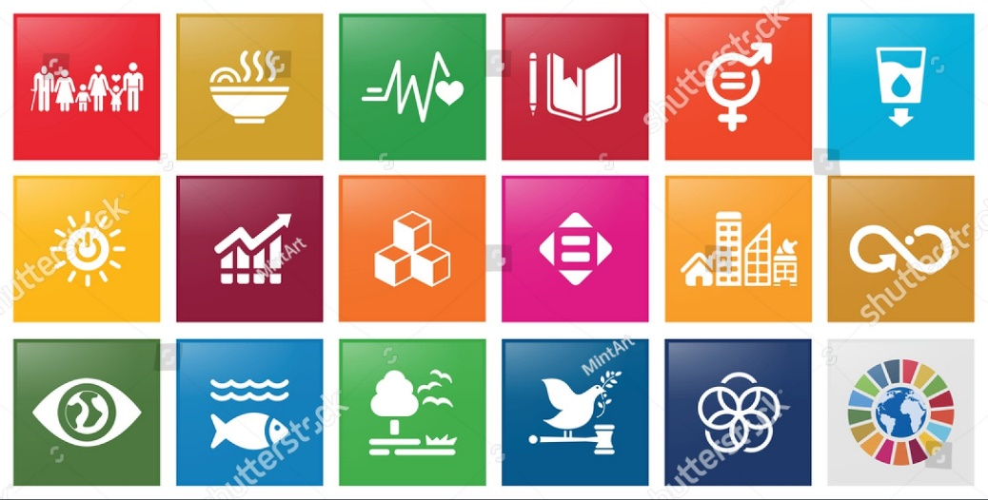
Tq-image-middle
URL | 1939135573 / MintArt / shutterstock.com

The colourful icons representing the 17 global goals succinctly summarise each goal but don’t tell the full expectation of each goal. In the table below, you can find the full description of each goal. Often, the additional detail will describe the scope of the goal; for instance, Goal 1 intends to end poverty, but in all its forms everywhere.6
United Nations. The Millennium Development Goals Report 2015 https://www.un.org/millenniumgoals/2015_MDG_Report/pdf/MDG 2015 rev (July 1).pdf

Goal 1 | End poverty in all its forms everywhere
Goal 2 | End hunger, achieve food security and improved nutrition and promote sustainable agriculture
Goal 3 | Ensure healthy lives and promote well-being for all at all ages
Goal 4 | Ensure inclusive and equitable quality education and promote lifelong learning opportunities for all
Goal 5 | Achieve gender equality and empower all women and girls
Goal 6 | Ensure availability and sustainable management of water and sanitation for all
Goal 7 | Ensure access to affordable, reliable, sustainable and modern energy for all
Goal 8 | Promote sustained, inclusive and sustainable economic growth, full and productive employment and decent work for all
Goal 9 | Build resilient infrastructure, promote inclusive and sustainable industrialisation and foster innovation
Goal 10 | Reduce inequality within and among countries
Goal 11 | Make cities and human settlements inclusive, safe, resilient and sustainable
Goal 12 | Ensure sustainable consumption and production patterns
Goal 13 | Take urgent action to combat climate change and its impacts
Goal 14 | Conserve and sustainably use the oceans, seas and marine resources for sustainable development
Goal 15 | Protect, restore and promote sustainable use of terrestrial ecosystems, sustainably manage forests, combat desertification, and halt and reverse land degradation and halt biodiversity loss
Goal 16 | Promote peaceful and inclusive societies for sustainable development, provide access to justice for all and build effective, accountable and inclusive institutions at all levels
Goal 17 | Strengthen the means of implementation and revitalise the Global Partnership for Sustainable Development

Tq-panel-video
Sustainable development goals: Improve like all around the globe (2:47)

Tq-panel-activity
Explore this animated, distorted, shaded, interactive global map to help convey how different countries fit into the climate change picture – both the causes and the risks.
The carbon map

The 5 Ps of Sustainable Development
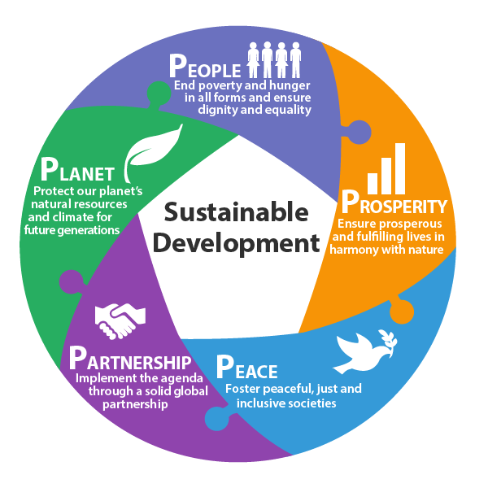
Tq-image-middle
URL | © Oneworldcentre

The 17 global goals build on the three pillars of sustainable development of people, planet, and prosperity by adding peace and partnership to improve the probability of success between 2015 and 2030. Fortunately, people, planet, prosperity, peace, and partnership all conveniently begin with ‘P’, so they have become known as the Five Ps of Sustainable Development.
The global goals are complex and interlinked, and the Five Ps are a simple means of dividing the Goals between the Ps of People, Planet, and Prosperity, Peace, and Partnership. While there is a range of Goals supporting People, Planet, and Prosperity, there is only one goal supporting Peace and Partnership, respectively. The interlinkages and integrated nature of the global goals are vital in ensuring that the purpose of the new Agenda is realised.
The Transforming, Our World Resolution, summarises the expected achievements for each of the Five Ps as follows, along with the associated Goals
United Nations. Transforming Our World – The 2030 Agenda for Sustainable Development https://sustainabledevelopment.un.org/content/documents/21252030 Agenda for Sustainable Development web.pdf
People – Sustainable Development Goals (SDG) 1, 2, 3, 4, 5, 6
We are determined to end poverty and hunger in all their forms and dimensions and ensure that all human beings can fulfil their potential in dignity, equality, and a healthy environment.
Prosperity – Sustainable Development Goals (SDG) 7, 8, 9, 10
We are determined to ensure that all human beings can enjoy prosperous and fulfilling lives and that economic, social and technological progress occurs in harmony with nature.
Planet – Sustainable Development Goals (SDG) 11, 12, 13, 14, 15
We are determined to protect the planet from degradation through sustainable consumption and production, sustainably managing its natural resources, and taking urgent action on climate change to support the needs of the present and future generations.
Peace – Sustainable Development Goals (SDG) 16
We are determined to foster peaceful, just and inclusive societies which are free from fear and violence. There can be no sustainable development without peace and no peace without sustainable development.
Partnership – Sustainable Development Goals (SDG) 17
We are determined to mobilise the means required to implement this Agenda through a revitalised global partnership for sustainable development. Based on a spirit of strengthened international solidarity – participation of all countries, stakeholders and people. Focusing on the needs of the poor and vulnerable.
Tq-image-middle
URL | © TAFE Queensland

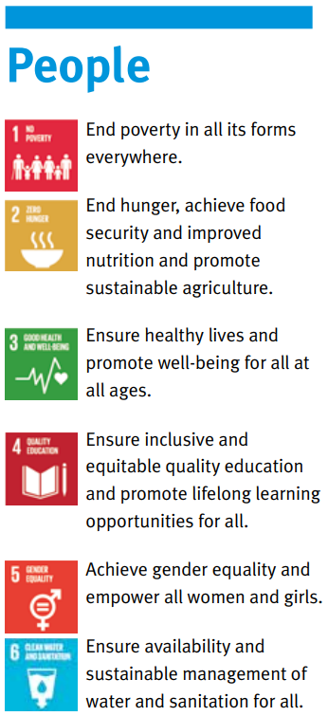 | 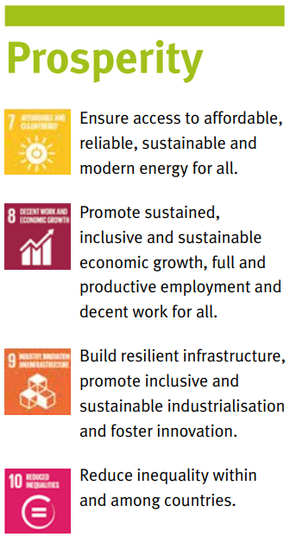 | 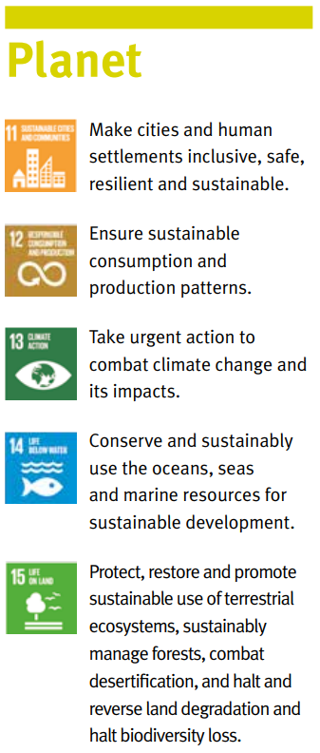 | 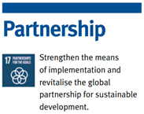  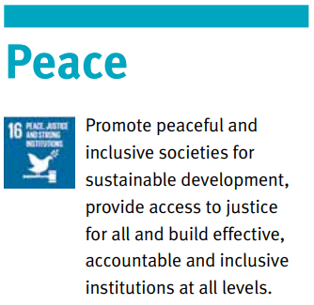

Global Goals in a Nutshell

Tq-image-middle
URL | 1515198656 / Adil Celebiyev StokPhoto / shutterstock.com
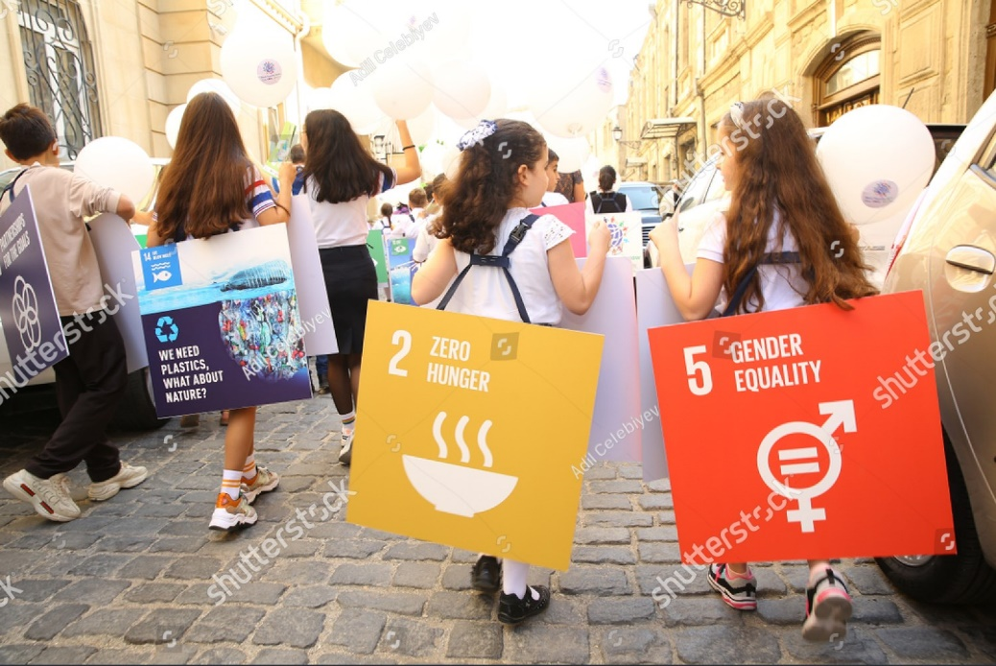
Our planet is more innovative, connected, and faster growing than ever before, yet we haven’t found solutions to global challenges like poverty, inequality and climate change. By working together, the global goals provide a framework to solve these challenges by 2030. For the first time in history, the goals and targets provide a mechanism to: implement a universal action plan, hold governments to account, and generate global cooperation.
Microsoft Educator Center. Teaching Sustainable Development Goals
https://education.microsoft.com/en-us/course/72e17f8e/7

A unified and unifying plan of action
The global goals focus on developing efforts on shared objectives. Development solutions need to be oriented in the same direction to prioritise matters and ensure no one is left behind. It is hoped that the global goals can be achieved with enough political will, investment, and action at all levels.

Holding governments accountable
The global goals provide a mechanism to hold governments accountable, with every United Nations Member State (193) agreeing to the framework. Citizens, including educators, young people and even children, will play an essential role in monitoring the implementation of the target and applying pressure on governments at all levels to ensure the most marginalised groups are reached. Our participation in teaching the global goals to others and encouraging their support is vital in this effort.

Bringing the world together
The global goals are built on the ideas of partnership and cooperation. Achieving the Goals and target will be impossible without the cooperation and participation of everyone. These Goals were created by the people, for the people, through one of the broadest participation processes in history. Civil society played an essential role in the design phase of the Goals (over 500,000 people participated through debates and consultations).

Universality
The global goals concern every one of us across the globe. The 2030 Agenda demonstrates that certain ideals and rights are universally shared for our cultural, economic, and political differences. The Goals are an opportunity to change the world for the better, but they depend on focussed and prioritised action. The actions of individuals will build to be the actions of the many.

Targets and Indicators
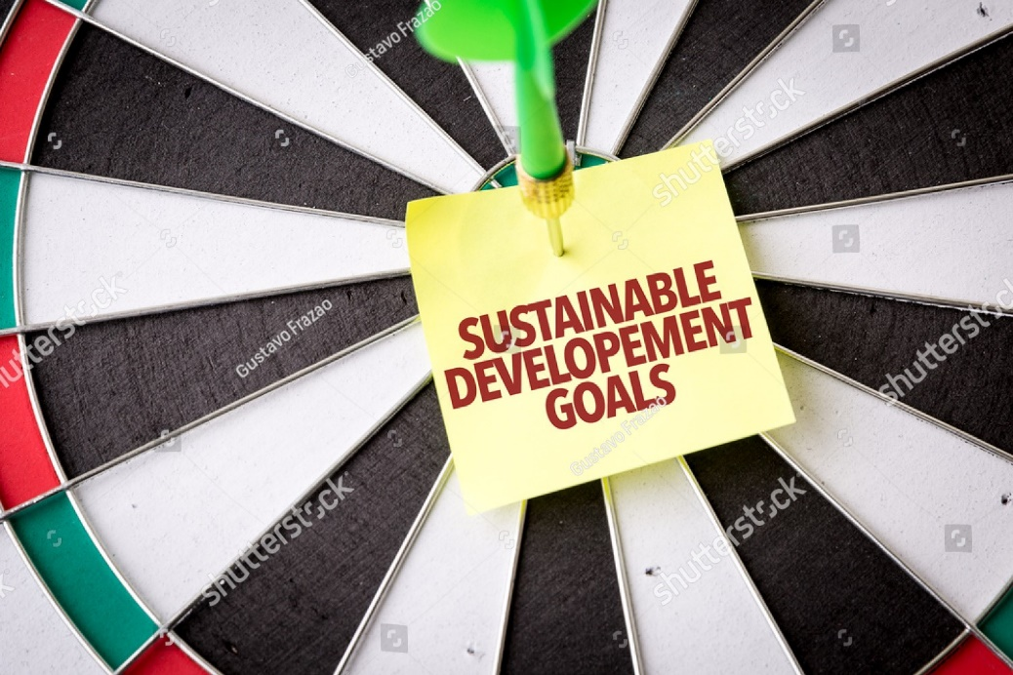
Tq-image-middle
URL | 512255095 / Gustavo Frazao / shutterstock.com

One hundred sixty-nine targets underpin the 17 global goals. The numbering system of targets is as follows: ‘outcome targets’ use numbers, whereas ‘means of implementation targets’ use numbers and letters. For example, Sustainable Development Goals (SDG) 6 has a total of 8 targets. The first six are outcome targets and are labelled targets 6.1 to 6.6. The final two targets are ‘means of implementation targets’ and are marked as targets 6.A and 6.B.
It should be noted that some of the targets are expected to be achieved in timeframes well before 2030. For example, target 3.6 indicates: ‘By 2020, halve the number of global deaths and injuries from road traffic accidents’ – this target was to be achieved within five years of 2015, not the 15 years allocated to many of the targets.
The global indicator framework was adopted by the General Assembly on 6 July 2017 and included 231 unique indicators. Interestingly, the total number of indicators listed in the global indicator framework of sustainable development goals (SDG) is 247; however, twelve indicators repeat under two or three different targets. As an example, 7.b.1 and 12.a.1 are the same: and will reflect: ‘Installed renewable energy-generating capacity in developing countries (in watts per capita)’. The global goal indicators should be disaggregated, where relevant, by income, sex, age, race, ethnicity, migratory status, disability and geographic location, or other characteristics.

United Nations. Global indicator framework for the Sustainable Development Goals and targets of the
2030 Agenda for Sustainable Development. https://unstats.un.org/sdgs/indicators/Global%20Indicator%20Framework%20after%202021%20refinement_Eng.pdf

Tq-comment
MM – please link ‘Global Indicator Framework after 2021 refinement_Eng.pdf’ located in the Files for MM folder to the link text in the Document panel below.

Tq-panel-document
- Global indicator framework for the Sustainable Development Goals and targets of the 2030 Agenda for Sustainable Development (PDF 392 KB)

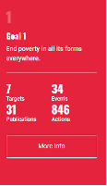
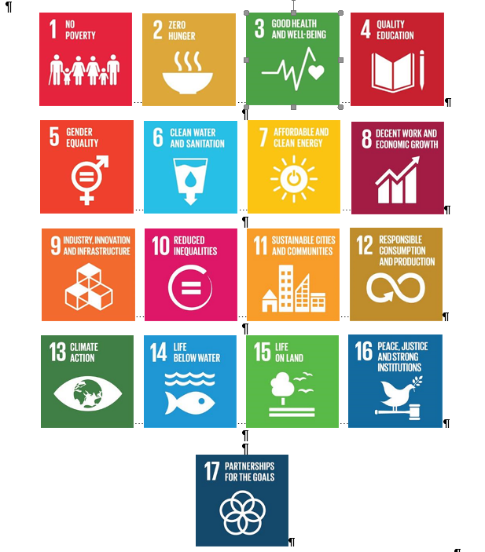
Global goals – facts and targets (Hover over each goal)

GOAL 1: No Poverty

Tq-image-middle
URL | 1715581324 / Nos SeaStar / shutterstock.com
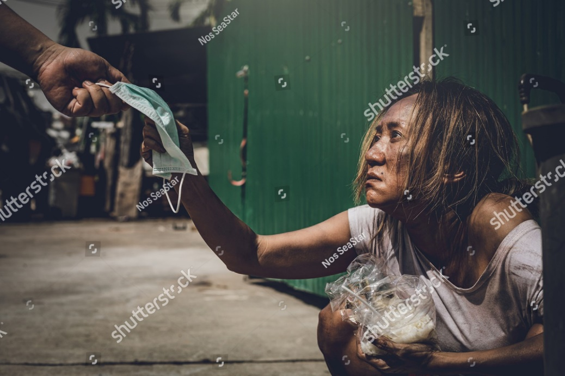
Poverty has many dimensions, but its causes include unemployment, social exclusion, and high vulnerability of specific populations to disasters, diseases and other phenomena which prevent them from being productive.

Facts
According to the most recent estimates, in 2015, 10 per cent of the world’s population or 734 million people, lived on less than $1.90 a day.
Even before COVID-19, baseline projections suggested that 6 per cent of the global population would still be living in extreme poverty in 2030, missing the target of ending poverty. The fallout from the pandemic threatens to push over 70 million people into extreme poverty.
One out of five children live in extreme poverty, and the adverse effects of poverty and deprivation in the early years have ramifications that can last a lifetime.
In 2016, 55 per cent of the world’s population – about 4 billion people – did not benefit from any form of social protection.

Tq-panel-weblink
- Goal 1: End poverty in all its forms everywhere

Targets
Eradicate extreme poverty by 2030 for anyone living on less than $1.25 (the current national definition of extreme poverty) a day.
Implement nationally appropriate social protection systems and measures for all, including floors, and by 2030 achieve substantial coverage of the poor and the vulnerable.
Ensure all men and women, particularly the poor and the vulnerable, have equal rights to economic resources, essential services, ownership and control over land and other forms of property, inheritance, natural resources, appropriate new technology and financial services, including microfinance by 2030.
Build the resilience of the poor and those in vulnerable situations and reduce their exposure and vulnerability to climate-related extreme events and other economic, social, environmental shocks and disasters by 2030.
Ensure significant mobilisation of resources from a variety of sources, including through enhanced development cooperation, to provide adequate and predictable means for developing countries, in particular least developed countries, to implement programmes and policies to end poverty in all its dimensions
Create sound policy frameworks at the national, regional and international levels, based on pro-poor and gender-sensitive development strategies, to support accelerated investment in poverty eradication actions

Tq-comment
MM – please link ‘1_Why-It-Matters-2020.pdf’ and ‘N1529189.pdf’ located in the Files for MM folder to the link text in the Document panel below.

Tq-panel-document
- No Poverty: Why it matters (PDF 523 KB)
- United Nations General Assembly – Resolution adopted by the General Assembly on 25 September 2014 (PDF 436 KB)

Tq-panel-weblink
- Goal 1: End poverty in all its forms everywhere

Goal 2: Zero Hunger
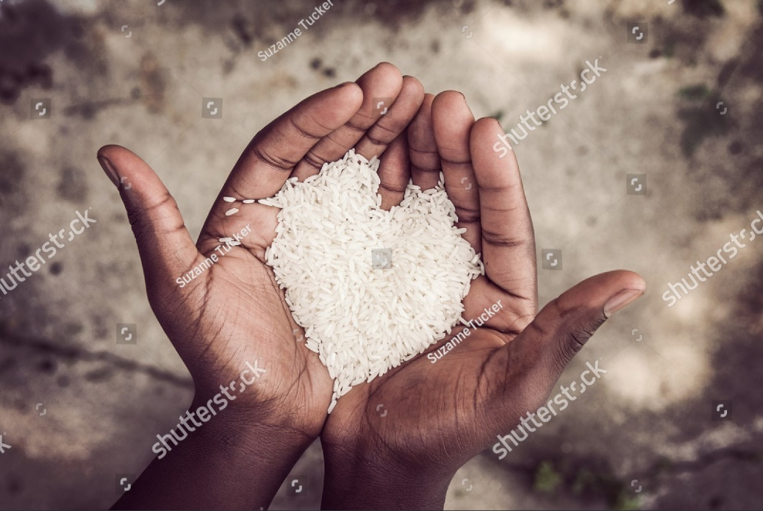
Tq-image-middle
URL | 433891159 / Suzanne Tucker / shutterstock.com

Extreme hunger and malnutrition remain a barrier to sustainable development and create a trap that people cannot easily escape. Hunger and malnutrition mean less productive individuals, who are more prone to disease and thus often unable to earn more and improve their livelihoods.

Facts
In 2019, close to 750 million – or nearly one in ten people in the world – were exposed to severe levels of food insecurity.
An estimated 2 billion people did not have regular access to safe, nutritious and sufficient food in 2019.
One hundred forty-four million children under age five were affected by stunting in 2019, with three quarters living in Southern Asia and sub-Saharan Africa.
In 2019, 6.9 per cent (or 47 million) children under five were affected by wasting or acute undernutrition, a condition caused by limited nutrient intake and infection.

Tq-panel-weblink
- Goal 2: End hunger, achieve food security and improved nutrition and promote sustainable agriculture

Targets
2.1
By 2030, end hunger and ensure access by all people, in particular the poor and people in vulnerable situations, including infants, to safe, nutritious and sufficient food all year round.
2.2
By 2030, end all forms of malnutrition, including achieving, by 2025, the internationally agreed targets on stunting and wasting in children under five years of age, and address the nutritional needs of adolescent girls, pregnant and lactating women and older persons.
2.3
By 2030, double the agricultural productivity and incomes of small-scale food producers, in particular women, indigenous peoples, family farmers, pastoralists and fishers, including through secure and equal access to land, other productive resources and inputs, knowledge, financial services, markets and opportunities for value addition and non-farm employment.
2.4
Ensure sustainable food production systems and implement resilient agricultural practices that increase productivity and production, help maintain ecosystems, strengthen capacity for adaptation to climate change, extreme weather, drought, flooding, and other disasters by 2030. To allow for a progressive improvement of land and soil quality.
2.5
Maintain the genetic diversity of seeds, cultivated plants, farmed and domesticated animals, related wild species through soundly managed and diversified seed and plant banks at national, regional and international levels by 2020. To promote access to and fair and equitable sharing of benefits from utilising genetic resources and associated traditional knowledge, as internationally agreed.
2.A
Increase investment, including enhanced international cooperation in rural infrastructure, agricultural research and extension services, technology development, and plant and livestock gene banks to enhance agricultural productive capacity in developing countries, mainly least developed countries.
2.B
Correct and prevent trade restrictions and distortions in world agricultural markets, including through the parallel elimination of all forms of agricultural export subsidies and all export measures with equivalent effect, following the mandate of the Doha Development Round.
2.C
Adopt measures to ensure the proper functioning of food commodity markets and their derivatives and facilitate timely access to market information, including food reserves, to help limit extreme food price volatility.

Goal 3: Good health and well being
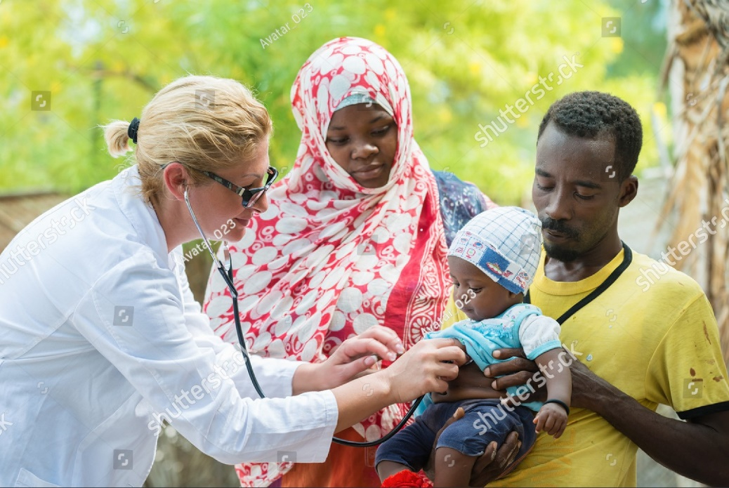
Tq-image-middle
URL | 608662319 / Avatar_023 / shutterstock.com

Ensuring healthy lives and promoting well-being is essential to building prosperous societies. Concerted efforts are required to achieve universal health coverage and sustainable financing for health, address the growing burden of communicable and non-communicable diseases, tackle antimicrobial resistance and environmental factors contributing to ill health.

Facts
In 2018 an estimated 6.2 million children and adolescents under the age of 15 died, mostly from preventable causes. 5.3 million deaths occurred in the first five years, with almost half of these in the first month of life.
Over 40 per cent of all countries have fewer than ten medical doctors per 10,000 people; over 55 per cent of countries have fewer than 40 nursing and midwifery personnel per 10,000 people.
Every day in 2017, approximately 810 women died from preventable causes related to pregnancy and childbirth.
Thirty-eight million people globally were living with HIV in 2019, and 25.4 million people accessed antiretroviral therapy.

Tq-panel-weblink
- Goal 3: Ensure healthy lives and promote well-being for all ages

Targets
3.1
By 2030, reduce the global maternal mortality ratio to less than 70 per 100,000 live births.
3.2
By 2030, end preventable deaths of newborns and children under five years of age, with all countries aiming to reduce neonatal mortality to at least as low as 12 per 1,000 live births and under-5 mortality to at least as low as 25 per 1,000 live births.
3.3
By 2030, end the epidemics of AIDS, tuberculosis, malaria and neglected tropical diseases and combat hepatitis, water-borne diseases and other infectious diseases.
3.4
By 2030, reduce by one-third premature mortality from non-communicable diseases through prevention and treatment and promote mental health and well-being.
3.5
Strengthen the prevention and treatment of substance abuse, including narcotic drug abuse and harmful use of alcohol.
3.6
Halve the number of global deaths and injuries from road traffic accidents by 2020.
3.7
By 2030, ensure universal access to sexual and reproductive healthcare services, including family planning, information and education, and the integration of reproductive health into national strategies and programmes.
3.8
Achieve universal health coverage, including financial risk protection, access to quality essential healthcare services and access to safe, effective, quality and affordable essential medicines and vaccines for all.
3.9
By 2030, substantially reduce deaths and illnesses from hazardous chemicals and air, water and soil pollution and contamination.
3.A
Strengthen the World Health Organization Framework Convention on tobacco control in all countries, as appropriate.
3.B
Support the research and development of vaccines and medicines for communicable and non-communicable diseases that primarily affect developing countries. Provide access to affordable essential medicines and vaccines, following the Doha Declaration on the TRIPS Agreement and Public Health, which affirms the right of developing countries to use to the full the provisions in the Agreement on Trade-Related Aspects of Intellectual Property Rights regarding flexibilities to protect public health, and, in particular, provide access to medicines for all.
3.C
Substantially increase health financing and the recruitment, development, training and retention of the health workforce in developing countries, especially in the least developed countries and small island developing States.
3.D
Strengthen the capacity of all countries, in particular developing countries, for early warning, risk reduction and management of national and global health risks.

Goal 4: Quality Education
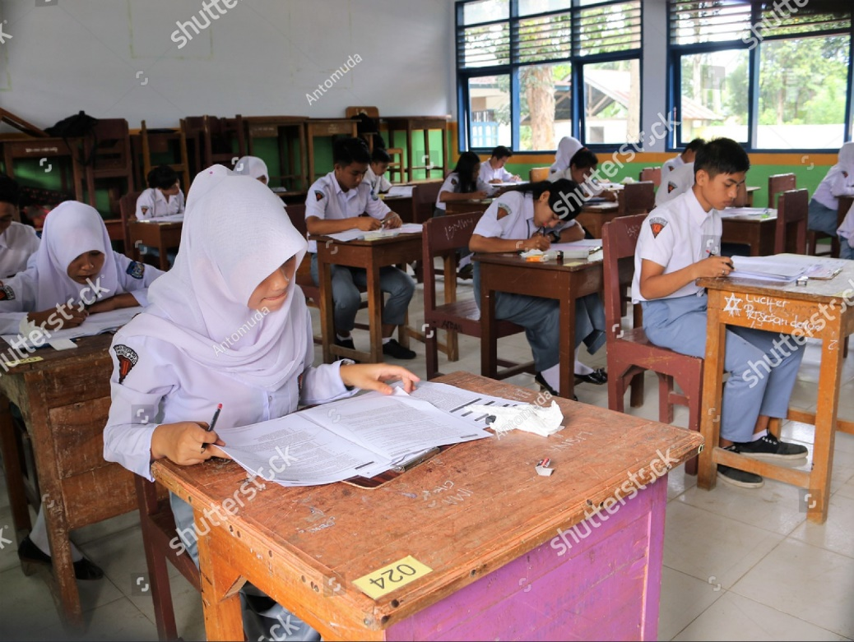
Tq-image-middle
URL | 1757354768 / Kaisarmuda / shutterstock.com

Education enables socioeconomic mobility upward and is a key to escaping poverty. Education helps reduce inequalities and reach gender equality and is crucial to fostering tolerance and more peaceful societies. Over the past decade, significant progress has been made towards increasing access to education and school enrolment rates at all levels, particularly for girls.

Facts
Before the coronavirus crisis, projections showed that more than 200 million children would be out of school, and only 60 per cent of young people would be completing upper secondary education in 2030.
Six hundred seventeen million youth worldwide lack basic mathematics and literacy skills.
Some 750 million adults – two-thirds of them women – remained illiterate in 2016.
Four million refugee children were out of school in 2017.
Tq-panel-weblink
- Goal 4: Ensure inclusive and equitable quality education and promote lifelong learning opportunities for all

Targets
4.1
By 2030, ensure that all girls and boys complete free, equitable and quality primary and secondary education leading to relevant and Goal-4 effective learning outcomes
4.2
By 2030, ensure that all girls and boys have access to quality early childhood development, care and preprimary education so that they are ready for primary education
4.3
By 2030, ensure equal access for all women and men to affordable and quality technical, vocational and tertiary education, including university
4.4
By 2030, substantially increase the number of youth and adults who have relevant skills, including technical and vocational skills, for employment, decent jobs and entrepreneurship
4.5
By 2030, eliminate gender disparities in education and ensure equal access to all levels of education and vocational training for the vulnerable, including persons with disabilities, indigenous peoples and children in vulnerable situations
4.6
By 2030, ensure that all youth and a substantial proportion of adults, both men and women, achieve literacy and numeracy
4.7
By 2030, ensure that all learners acquire the knowledge and skills needed to promote sustainable development, including, among others, through education for sustainable development and sustainable lifestyles, human rights, gender equality, promotion of a culture of peace and non-violence, global citizenship and appreciation of cultural diversity and culture’s contribution to sustainable development
4.A
Build and upgrade education facilities that are child, disability and gender sensitive and provide safe, nonviolent, inclusive and effective learning environments for all
4.B
By 2020, substantially expand globally the number of scholarships available to developing countries, in particular, least developed countries, small island developing States and African countries, for enrolment in higher education, including vocational training and information and communications technology, technical, engineering and scientific programmes, in developed countries and other developing countries
4.C
By 2030, substantially increase the supply of qualified teachers, including through international cooperation for teacher training in developing countries, especially least developed countries and small island developing states.

Closer look

Let’s take a deeper dive into SDG 4 - Ensure inclusive and equitable quality education and promote lifelong learning opportunities for all. Specifically, four targets relate to technical and vocational education and training and are relevant to Queensland TAFE. Of the ten targets for Sustainable Development Goals (SDG) 4, targets 4.3, 4.4, 4.6, and 4.7 are particularly appropriate to the target audience and services delivered by Queensland TAFE. Indeed, this orientation is a natural part of target 4.7.

Targets
4.3 | By 2030, ensure equal access for all women and men to affordable and quality technical, vocational and tertiary education, including university
4.4 | By 2030, substantially increase the number of youth and adults who have relevant skills, including technical and vocational skills, for employment, decent jobs and entrepreneurship
4.6 | By 2030, ensure that all youth and a substantial proportion of adults, both men and women, achieve literacy and numeracy
4.7 | By 2030, ensure that all learners acquire the knowledge and skills needed to promote sustainable development, including, among others, through education for sustainable development and sustainable lifestyles, human rights, gender equality, promotion of a culture of peace and non-violence, global citizenship and appreciation of cultural diversity and culture’s contribution to sustainable development

Each of these targets only has one indicator, as seen below. The data collected is segregated to provide a greater level of meaningful information and potential for tracking trends. For example, the data collected for Indicator 4.3.3, at a minimum, are segregated by sex.

Targets | Indicators
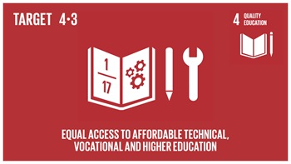 | 4.3.1 Participation rate of youth and adults in formal and non-formal education and training in the previous 12 months, by sex.
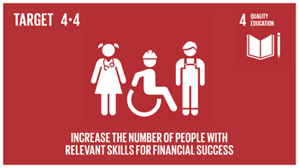 | 4.4.1 Proportion of youth and adults with information and communications technology (ICT) skills, by type of skill
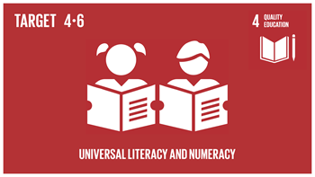 | 4.6.1 Proportion of population in a given age group achieving at least a fixed level of proficiency in functional (a) literacy and (b) numeracy skills by sex.
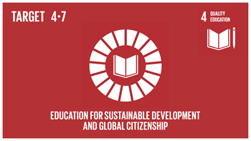 | 4.7.1 Extent to which (i) global citizenship education and (ii) education for sustainable development are mainstreamed in (a) national education policies; (b) curricula; (c) teacher education, and (d) student assessment

Goal 5: Gender equality
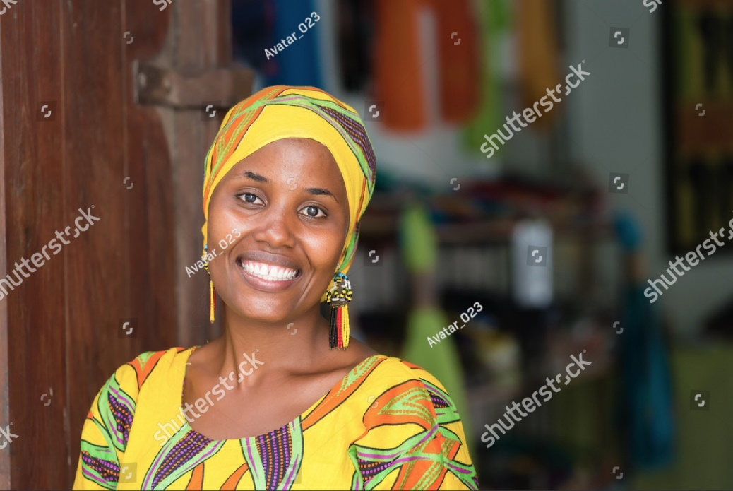
Tq-image-middle
URL | 647996635 / Avatar_023 / shutterstock.com

Women and girls represent half of the world’s population and therefore also half of its potential. But, today, gender inequality persists everywhere and stagnates social progress. Women continue to be underrepresented at all levels of political leadership. Across the globe, women and girls perform a disproportionate share of unpaid domestic work. Inequalities faced by girls can begin right at birth and follow them all their lives.

Facts
Globally, 750 million women and girls were married before 18, and at least 200 million women and girls in 30 countries have undergone female genital mutilation.
In 18 countries, husbands can legally prevent their wives from working; in 39 countries, daughters and sons do not have equal inheritance rights; 49 countries lack laws protecting women from domestic violence.
One in five women and girls, including 19 per cent of women and girls aged 15 to 49, have experienced physical and or sexual violence by an intimate partner within the last twelve months. Yet, 49 countries have no laws that specifically protect women from such violence.
While women have made substantial inroads into political office worldwide, their representation in national parliaments at 23.7 per cent is still far from parity.

Tq-panel-weblink
- Goal 5: Achieve gender equality and empower all women and girls

Targets
5.1
End all forms of discrimination against all women and girls everywhere
5.2
Eliminate all forms of violence against all women and girls in public and private spheres, including trafficking and sexual and other types of exploitation
5.3
Eliminate all harmful practices, such as child, early and forced marriage and female genital mutilation
5.4
Recognise and value unpaid care and domestic work through the provision of public services, infrastructure and social protection policies and the promotion of shared responsibility within the household and the family as nationally appropriate
5.5
Ensure women’s full and effective participation and equal opportunities for leadership at all levels of decision-making in political, economic and public life
5.6
Ensure universal access to sexual and reproductive health and reproductive rights as agreed under the Programme of Action of the International Conference on Population and Development and the Beijing Platform for Action and the outcome documents of their review conferences
5.A
Undertake reforms to give women equal rights to economic resources, as well as access to ownership and control over land and other forms of property, financial services, inheritance and natural resources, under national laws
5.B
Enhance the use of enabling technology, in particular information and communications technology, to promote the empowerment of women
5.C
Adopt and strengthen sound policies and enforceable legislation to promote gender equality and the empowerment of all women and girls at all levels.

Goal 6: Clean water and sanitation
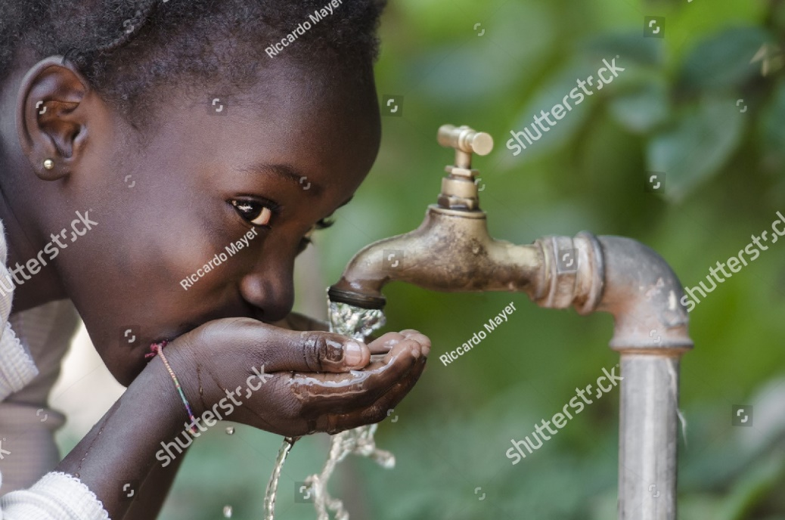
Tq-image-middle
URL | 276445445 / Riccardo Mayer / shutterstock.com

Access to water, sanitation and hygiene is a human right. The water demand has outpaced population growth, and half the world’s population is already experiencing severe water scarcity at least one month a year. Water is essential not only to health but also to poverty reduction, food security, peace and human rights, ecosystems and education. Nevertheless, countries face growing challenges linked to water scarcity, water pollution, degraded water-related ecosystems and cooperation over transboundary water basins.

Facts
At least 892 million people continue to practice open defecation.
Women and girls are responsible for water collection in 80 per cent of households without access to water on-premises.
2.4 billion people lack access to essential sanitation services, such as toilets or latrines
More than 80 per cent of wastewater resulting from human activities is discharged into rivers or sea without any pollution removal,
Tq-panel-weblink
- Goal 6: Ensure availability and sustainable management of water and sanitation for all

Targets
6.1
By 2030, achieve universal and equitable access to safe and affordable drinking water for all
6.2
By 2030, achieve access to adequate and equitable sanitation and hygiene for all and end open defecation, paying particular attention to the needs of women and girls and those in vulnerable situations
6.3
By 2030, improve water quality by reducing pollution, eliminating dumping and minimising release of hazardous chemicals and materials, halving the proportion of untreated wastewater and substantially increasing recycling and safe reuse globally
6.4
By 2030, substantially increase water-use efficiency across all sectors and ensure sustainable withdrawals and supply of freshwater to address water scarcity and substantially reduce the number of people suffering from water scarcity
6.5
By 2030, implement integrated water resources management at all levels, including through transboundary cooperation as appropriate
6.6
By 2020, protect and restore water-related ecosystems, including mountains, forests, wetlands, rivers, aquifers and lakes
6.A
By 2030, expand international cooperation and capacity-building support to developing countries in water- and sanitation-related activities and programmes, including water harvesting, desalination, water efficiency, wastewater treatment, recycling and reuse technologies
6.B
Support and strengthen the participation of local communities in improving water and sanitation management

Goal 7: Affordable and clean energy
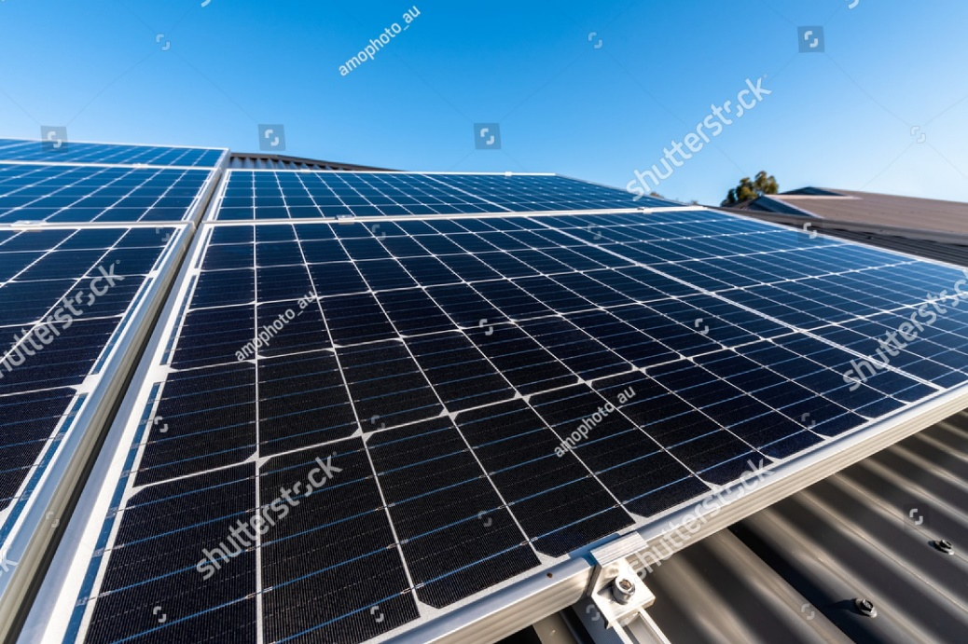
Tq-image-middle
URL | 1776646328 / myphotobank.com.au / shutterstock.com

A well-established energy system supports all sectors: from businesses, medicine and education to agriculture, infrastructure, communications and high technology. Access to electricity in poorer countries has begun to accelerate, energy efficiency continues to improve, and renewable energy is making impressive gains. Nevertheless, more focused attention is needed to improve access to clean and safe cooking fuels and technologies for 2.8 billion people.

Facts
Thirteen per cent of the global population still lacks access to modern electricity. three billion people rely on wood, coal, charcoal or animal waste for cooking and heating
Energy is the dominant contributor to climate change, accounting for around 60 per cent of total global greenhouse gas emissions.
Indoor air pollution from using combustible fuels for household energy caused 4.3 million deaths in 2012, with women and girls accounting for 6 out of every 10 of these.

Tq-panel-weblink
- Goal 7: Ensure access to affordable, reliable, sustainable and modern energy for all

Targets
7.1
By 2030, ensure universal access to affordable, reliable and modern energy services
7.2
By 2030, increase the share of renewable energy in the global energy mix substantially
7.3
By 2030, double the global rate of improvement in energy efficiency
7.A
By 2030, enhance international cooperation to facilitate access to clean energy research and technology, including renewable energy, energy efficiency, advanced and cleaner fossil-fuel technology, and promote investment in energy infrastructure and clean energy technology.
7.B
By 2030, expand infrastructure and upgrade technology for supplying modern and sustainable energy services for all in developing countries, mainly least developed countries, small island developing states, and land-locked developing countries, according to their respective programmes of support.

Goal 8: Decent work and economic growth
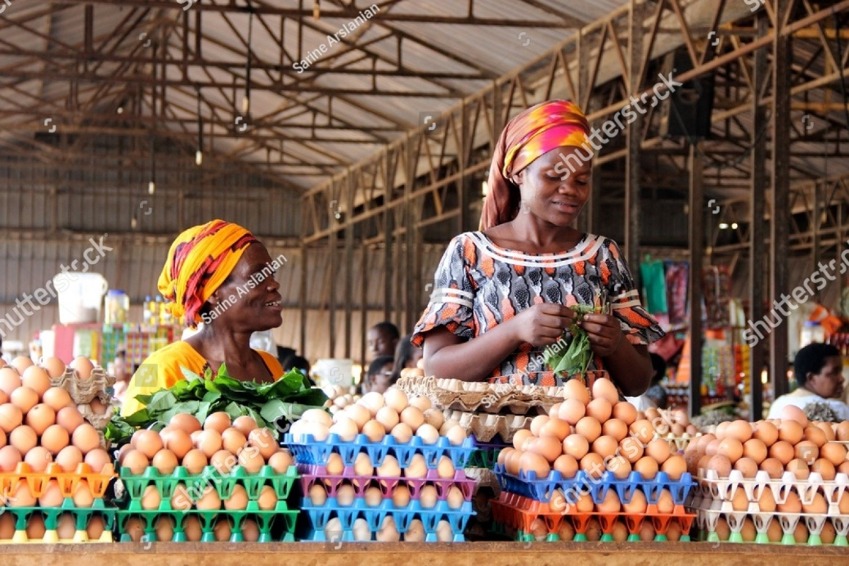
Tq-image-middle
URL | 404211841 / Sarine Arslania / shutterstock.com
Sustained and inclusive economic growth can drive progress, create decent jobs for all and improve living standards. Even before the outbreak of COVID-19, one in five countries – home to billions of people living in poverty – were likely to see per capita incomes declined in 2020. Now, the economic and financial shocks associated with the pandemic—such as disruptions to industrial production, financial market volatility, and rising insecurity—are derailing the already moderate economic growth and compounding heightened risks from other factors.

Facts
The global unemployment rate in 2017 was 5.6per cent, down from 6.4per cent in 2000.
Men earn 12.5per cent more than women in 40 out of 45 countries with data.
The global gender pay gap stands at 23 per cent globally, and without decisive action, it will take another 68 years to achieve equal pay. Women’s labour force participation rate is 63 per cent, while that of men is 94 per cent.
Despite their increasing presence in public life, women continue to do 2.6 times the unpaid care and domestic work than men.

Tq-panel-weblink
- Goal 8: Promote sustained, inclusive and sustainable economic growth, full and productive employment and decent work for all

Targets
8.1
Sustain per capita economic growth per national circumstances and, in particular, at least 7 per cent gross domestic product growth per annum in the least developed countries.
8.2
Achieve higher levels of economic productivity through diversification, technological upgrading and innovation, including a focus on high-value added and labour-intensive sectors.
8.3
Promote development-oriented policies that support productive activities, decent job creation, entrepreneurship, creativity and innovation. Encourage start-ups and growth of micro, small and medium-sized enterprises plus access to financial services.
8.4
Improve progressively, through 2030, global resource efficiency in consumption and production and endeavour to decouple economic growth from environmental degradation, following the 10-year framework of programmes on sustainable consumption and production, with developed countries taking the lead.
8.5
By 2030, achieve full and productive employment and decent work for all women and men, including for young people and persons with disabilities, and equal pay for work of equal value
8.6
By 2020, substantially reduce the proportion of youth not in employment, education or training
8.7
Take immediate and effective measures to eradicate forced labour, end modern slavery and human trafficking and secure the prohibition and elimination of the worst forms of child labour, including recruitment and use of child soldiers, and by 2025 end child labour in all its forms
8.8
Protect labour rights and promote safe and secure working environments for all workers, including migrant workers, in particular, women migrants, and those in precarious employment
8.9
By 2030, devise and implement policies to promote sustainable tourism that creates jobs and promotes local culture and products
8.10
Strengthen the capacity of domestic financial institutions to encourage and expand access to banking, insurance and financial services for all
8.A
Increase Aid for Trade support for developing countries, in particular, least developed countries, including through the Enhanced Integrated Framework for Trade-Related Technical Assistance to Least Developed Countries
8.B
By 2020, develop and operationalise a global strategy for youth employment and implement the Global Jobs Pact of the International Labour Organization

Goal 9: Industry, innovation, and infrastructure

Tq-image-middle
URL | 1308477907 / Klintsou Ihar / shutterstock.com

Economic growth, social development, and climate action heavily depend on infrastructure investments, sustainable industrial development, and technological progress. In the face of a rapidly changing global economic landscape and increasing inequalities, sustained growth must include industrialisation that makes opportunities accessible to all people and is supported by innovation and resilient infrastructure.

Facts
In 2018, 96 per cent of the world’s population lived within reach of a mobile-cellular signal, and 90 per cent of people could access the internet through a third-generation (3G) or higher-quality network.
Sixteen per cent of the global population does not have access to mobile broadband networks.
In 2019, the amount of new renewable power capacity added (excluding large hydro) was the highest ever, at 184 gigawatts, 20GW more than in 2018.
Developing countries continued to outpace developed economies in renewables investment. In 2019, they committed $152.2 billion, compared to $130 billion for developed countries.

Tq-panel-weblink
Goal 9: Build resilient infrastructure, promote inclusive and sustainable industrialisation and foster innovation

Targets
9.1
Develop quality, reliable, sustainable and resilient infrastructure, including regional and transborder infrastructure, to support economic development and human well-being, with a focus on affordable and equitable access for all
9.2
Promote inclusive and sustainable industrialisation and, by 2030, significantly raise industry’s share of employment and gross domestic product, in line with national circumstances, and double its share in the least developed countries
9.3
Increase the access of small-scale industrial and other enterprises, in particular in developing countries, to financial services, including affordable credit, and their integration into value chains and markets
9.4
By 2030, upgrade infrastructure and retrofit industries to make them sustainable, with increased resource-use efficiency and greater adoption of clean and environmentally sound technologies and industrial processes, with all countries taking action per their respective capabilities
9.5
Enhance scientific research, upgrade the technological capabilities of industrial sectors in all countries, in particular developing countries, including, by 2030, encouraging innovation and substantially increasing the number of research and development workers per 1 million people and public and private research and development spending
9.A
Facilitate sustainable and resilient infrastructure development in developing countries through enhanced financial, technological and technical support to African countries, least developed countries, landlocked developing countries and small island developing States 18
9.B
Support domestic technology development, research and innovation in developing countries, including by ensuring a conducive policy environment for, among other things, industrial diversification and value addition to commodities
9.C
Significantly increase access to information and communications technology and strive to provide universal and affordable access to the internet in the least developed countries by 2020.

Goal 10: Reduced inequalities
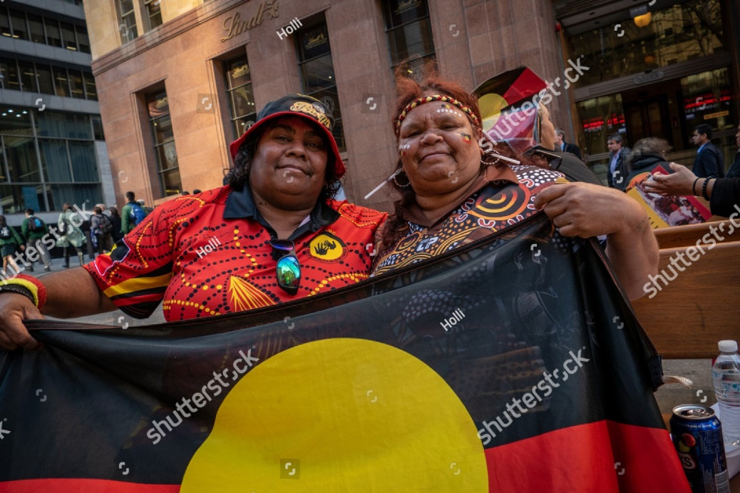
Tq-image-middle
URL | 1291247134 / Holli / shutterstock.com

Inequalities based on income, sex, age, disability, sexual orientation, race, class, ethnicity, religion and opportunity continue to persist worldwide. Inequality threatens long-term social and economic development, harms poverty reduction and destroys people’s sense of fulfilment and self-worth, which in turn can breed crime, disease and environmental degradation.

Facts
Evidence from developing countries shows that children in the poorest 20 per cent of the population are still up to three times more likely to die before their fifth birthday than children in the wealthiest quintiles.
Despite overall declines in maternal mortality in most developing countries, women in rural areas are still up to three times more likely to die while giving birth than women living in urban centres.
Of the one billion population of persons with disabilities, 80per cent live in developing countries.
Only 28 per cent of persons with significant disabilities have access to disability benefits globally, and only 1per cent in low-income countries.

Tq-panel-weblink
Goal 10: Reduce inequality within and among countries

Targets
10.1
By 2030, progressively achieve and sustain income growth of the bottom 40 per cent of the population at a rate higher than the national average.
10.2
By 2030, empower and promote the social, economic and political inclusion of all, irrespective of age, sex, disability, race, ethnicity, origin, religion or financial or status.
10.3
Ensure equal opportunity and reduce inequalities of outcome, including by eliminating discriminatory laws, policies and practices and promoting appropriate legislation, policies and action in this regard.
10.4
Adopt policies, especially fiscal, wage and social protection policies, and progressively achieve greater equality.
10.5
Improve the regulation and monitoring of global financial markets and institutions and strengthen the implementation of such rules.
10.6
Ensure enhanced representation and voice for developing countries in decision-making in global international economic and financial institutions to deliver more effective, credible, accountable and legitimate institutions.
10.7
Facilitate orderly, safe, regular and responsible migration and mobility of people, including implementing planned and well-managed migration policies.
10.A
Implement the special and differential treatment principle for developing countries, mainly least developed countries, following World Trade Organization agreements.
10.B
Encourage official development assistance and financial flows, including foreign direct investment, to States where the need is greatest, in particular, least developed countries, African countries, small island developing states and landlocked developing countries, per their national plans and programmes
10.C
By 2030, reduce to less than 3 per cent the transaction costs of migrant remittances and eliminate remittance corridors with costs higher than 5 per cent

Goal 11: Sustainable cities and communities

Tq-image-middle
URL | 1381295207 / Anna Ostanina / shutterstock.com

Over 90 per cent of COVID19 cases occur in urban areas, with the 1 billion residents of the world’s densely populated slums being hit the hardest. Before the pandemic, rapid urbanisation meant that 4 billion people – over half of the global population – in the world’s cities faced worsening air pollution, inadequate infrastructure and services, and unplanned urban sprawl. Rapid urbanisation exerts pressure on fresh water supplies, sewage, the living environment, and public health.

Facts
Half of humanity – 3.5 billion people – lives in cities today, and 5 billion people are projected to live in cities by 2030.
The world’s cities occupy just 3 per cent of the Earth’s land but account for 60-80 per cent of energy consumption and 75 per cent of carbon emissions.
Cities account for between 60 and 80 per cent of energy consumption and generate as much as 70per cent of human-induced greenhouse gas emissions
By 2050 70 per cent of the world population is predicted to live in urban settlements.

Tq-panel-weblink
- Goal 11: Make cities and human settlements inclusive, safe, resilient and sustainable

Targets
11.1
By 2030, ensure access for all to adequate, safe and affordable housing and essential services and upgrade slums
11.2
By 2030, provide access to safe, affordable, accessible and sustainable transport systems for all, improving road safety, notably by expanding public transport, with particular attention to the needs of those in vulnerable situations, women, children, persons with disabilities and older
persons
11.3
By 2030, enhance inclusive and sustainable urbanisation and capacity for participatory, integrated and sustainable human settlement planning and management in all countries
11.4
Strengthen efforts to protect and safeguard the world’s cultural and natural heritage
11.5
By 2030, significantly reduce the number of deaths and the number of people affected and substantially decrease the direct economic losses relative to the global gross domestic product caused by disasters, including water-related disasters, with a focus on protecting the poor and people in vulnerable situations
11.6
By 2030, reduce the adverse per capita environmental impact of cities, including by paying particular attention to air quality and municipal and other waste management
11.7
By 2030, provide universal access to safe, inclusive and accessible, green and public spaces, in particular for women and children, older persons and persons with disabilities
11.A
Support positive economic, social and environmental links between urban, peri-urban and rural areas by strengthening national and regional development planning
11.B
By 2020, substantially increase the number of cities and human settlements adopting and implementing integrated policies and plans towards inclusion, resource efficiency, mitigation and adaptation to climate change, resilience to disasters, and develop and implement, in line with the Sendai Framework for Disaster Risk Reduction 2015-2030, holistic disaster risk management at all levels
11.C
Support least developed countries, including financial and technical assistance, in building sustainable and resilient buildings utilising local materials.

Goal 12: Responsible consumption and production

Tq-image-middle
URL | 1756593794 / Daria Nipot / shutterstock.com
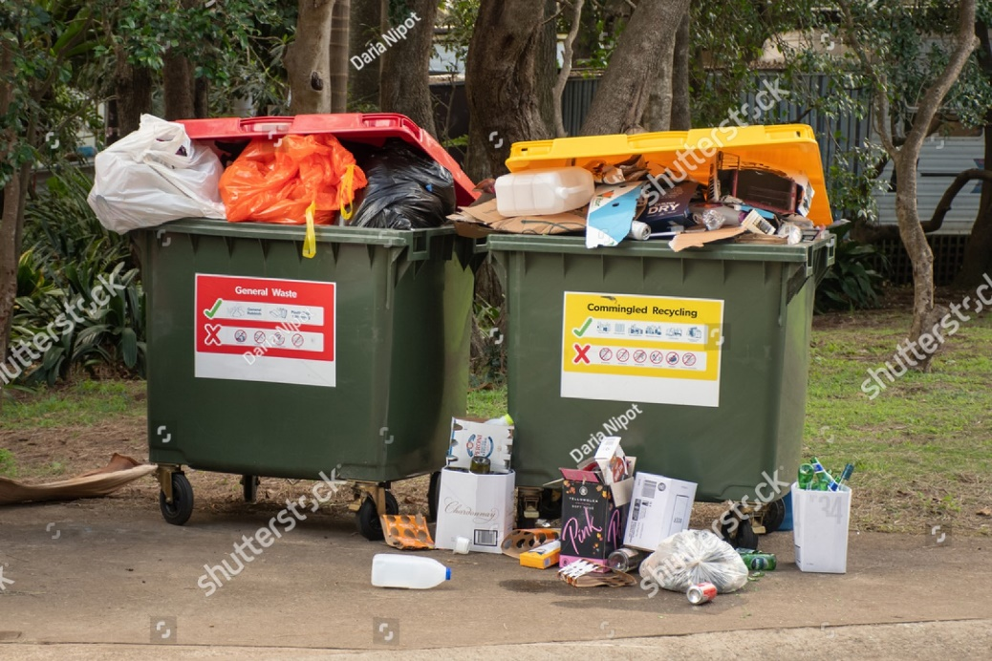
Over the last century, economic and social progress has been accompanied by environmental degradation that is endangering the very systems on which our future development and survival depend. COVID-19 offers an opportunity to develop recovery plans that will reverse current trends and shift our consumption and production patterns to a more sustainable course. A successful transition will mean improvements in resource efficiency, consideration of the entire life cycle of economic activities, and active engagement in multilateral environmental agreements.

Facts
According to the latest projections, the global population could grow to around 8.5 billion in 2030, 9.7 billion in 2050. The equivalent of almost three planets could be required to provide the natural resources needed to sustain current lifestyles.
Agriculture (including irrigation, livestock and aquaculture) is the largest water consumer, accounting for 69per cent of annual water withdrawals globally. Industry (including power generation) accounts for 19 per cent and households for 12 per cent.
The global electrification rate reached 89per cent in 2017 (from 83per cent in 2010), still leaving about 840 million people without access.
Each year, an estimated 1/3 of all food produced – equivalent to 1.3 billion tons worth around $1 trillion – ends up rotting in the bins of consumers and retailers or spoiling due to poor transportation and harvesting practices.

Tq-panel-weblink
Goal 12: Ensure sustainable consumption and production patterns

Targets
12.1
Implement the 10-year framework of programmes on sustainable consumption and production, all countries taking action, with developed countries taking the lead, taking into account the development and capabilities of developing countries
12.2
By 2030, achieve the sustainable management and efficient use of natural resources
12.3
By 2030, halve per capita global food waste at the retail and consumer levels and reduce food losses along production and supply chains, including post-harvest losses
12.4
By 2020, achieve the environmentally sound management of chemicals and all wastes throughout their life cycle, following agreed international frameworks, and significantly reduce their release to air, water and soil to minimise their adverse impacts on human health and the environment
12.5
By 2030, substantially reduce waste generation through prevention, reduction, recycling and reuse
12.6
Encourage companies, large and transnational companies, to adopt sustainable practices and to integrate sustainability information into their reporting cycle
12.7
Promote public procurement practices that are sustainable, following national policies and priorities
12.8
By 2030, ensure that people everywhere have the relevant information and awareness for sustainable development and lifestyles in harmony with nature
12.A
Support developing countries to strengthen their scientific and technological capacity to move towards more sustainable patterns of consumption and production
12.B
Develop and implement tools to monitor sustainable development impacts for sustainable tourism that creates jobs and promotes local culture and products
12.C
Rationalise inefficient fossil-fuel subsidies that encourage wasteful consumption by removing market distortions, per national circumstances. Restructuring taxation and phasing harmful subsidies, where they exist, to reflect their environmental impacts, taking into account specific needs and conditions of developing countries and minimising the possible adverse effects on their development to ensure protection for the poor and affected communities.

Goal 13: Climate action
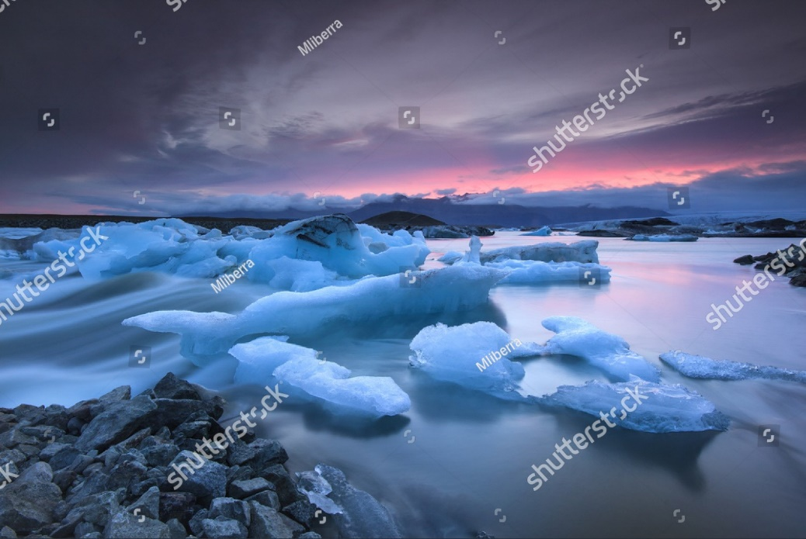
Tq-image-middle
URL | 265013873 / Mateusz Liberra / shutterstock.com

The climate crisis continues unabated as the global community shies away from the total commitment required for its reversal. 2010-2019 was the warmest decade ever recorded, bringing massive wildfires, hurricanes, droughts, floods and other climate disasters across continents.

Facts
From 1880 to 2012, the average global temperature increased by 0.85°C. In other words, for every degree of temperature increase, grain yields decline by about 5 per cent. Maise, wheat and other major crops have experienced significant yield reductions at the global level of 40 megatons per year between 1981 and 2002 due to a warmer climate.
Oceans have warmed, snow and ice have diminished, and the sea level has risen. From 1901 to 2010, the global average sea level rose by 19 cm as oceans expanded due to warming and ice melted. The Arctic’s sea ice extent has shrunk in every successive decade since 1979, with 1.07 million km² of ice loss every decade.
Global emissions of carbon dioxide (CO2) have increased by almost 50 per cent since 1990.
Using a wide array of technological measures and changes in behaviour, it is still possible to limit the increase in global mean temperature to two degrees Celsius above pre-industrial levels.

Tq-panel-weblink
Goal 13: Take urgent action to combat climate change and its impacts*
* Acknowledging that the United Nations Framework Convention on Climate Change is the primary international, intergovernmental forum for negotiating the global response to climate change.

Targets
13.1 Strengthen resilience and adaptive capacity to climate-related hazards and natural disasters in all countries.
13.2 Integrate climate change measures into national policies, strategies and planning.
13.3 Improve education, awareness-raising and human and institutional capacity on climate change mitigation, adaptation, impact reduction and early warning.
13.A
Implement the commitment undertaken by developed countries to the United Nations Framework Convention on climate change to a goal of mobilising jointly $100 billion annually by 2020 from all sources. To address the needs of developing countries in the context of meaningful mitigation actions and transparency on implementation and fully operationalise the Green Climate Fund through its capitalisation as soon as possible.
13.B
Promote mechanisms for raising capacity for effective climate change-related planning and management in the least developed countries and small island developing States, including focusing on women, youth and local and marginalised communities.

Goal 14: Life below water
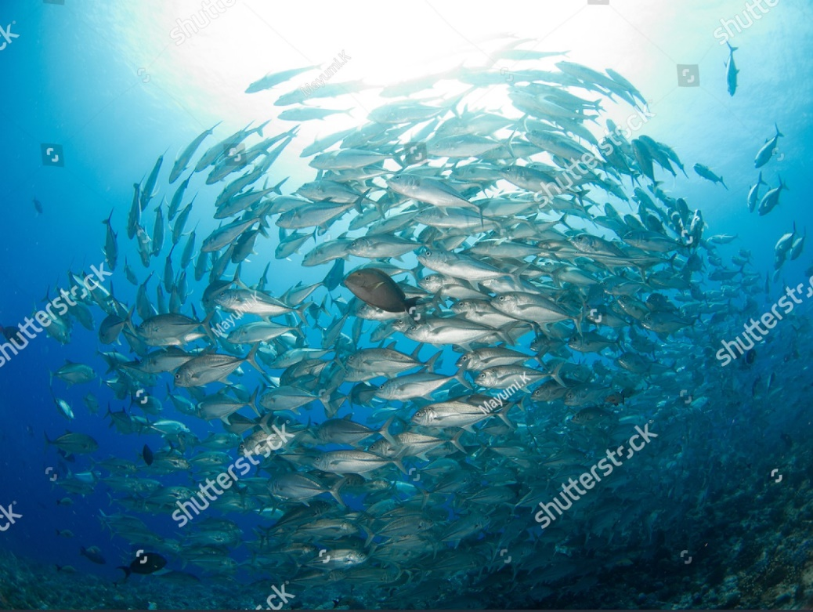
Tq-image-middle
URL | 1919465747 / Mayumi.K / shutterstock.com

Oceans are our planet’s life support and regulate the global climate system. They are the world’s largest ecosystem, home to nearly a million known species and containing the vast untapped potential for scientific discovery. Oceans and fisheries continue to support the global population’s economic, social and environmental needs. Despite the critical importance of conserving oceans, decades of irresponsible exploitation have led to an alarming level of degradation.

Facts
Oceans absorb about 30 per cent of carbon dioxide produced by humans, buffering the impacts of global warming.
Over three billion people depend on marine and coastal biodiversity for their livelihoods.
Roughly 80per cent of marine and coastal pollution originates on land – including agricultural run-off, pesticides, plastics and untreated sewage.
Sustainable and climate-resilient transport, including maritime transport, is key to sustainable development. Around 80 per cent of the volume of international trade in goods is carried by sea, and the percentage is even higher for most developing countries.

Tq-panel-weblink
Goal 14: Conserve and sustainably use the oceans, seas and marine resources for sustainable development

Targets
14.1
By 2025, prevent and significantly reduce marine pollution of all kinds, particularly from land-based activities, including marine debris and nutrient pollution.
14.2
By 2020, sustainably manage and protect marine and coastal ecosystems to avoid significant adverse impacts, including strengthening their resilience, and take action for their restoration to achieve healthy and productive oceans.
14.3
Minimise and address the impacts of ocean acidification, including through enhanced scientific cooperation at all levels.
14.4
By 2020, effectively regulate harvesting eliminate overfishing, illegal, unreported and unregulated fishing and destructive fishing practices. Implement science-based management plans to restore fish stocks in the shortest time feasible, at levels that can produce maximum sustainable yield as determined by their biological characteristics.
14.5
By 2020, conserve at least 10 per cent of coastal and marine areas, consistent with national and international law and based on the best available scientific information.
14.6
By 2020, prohibit certain forms of fisheries subsidies that contribute to overcapacity and overfishing. Eliminate subsidies that contribute to illegal, unreported and unregulated fishing. Refrain from introducing new subsidies, recognising that appropriate and effective special and differential treatment for developing and least developed countries should be an integral part of the World Trade Organization fisheries subsidies negotiation.
14.7
By 2030, increase the economic benefits to Small Island developing States and least developed countries from the sustainable use of marine resources, including sustainable management of fisheries, aquaculture and tourism.
14.A
Increase scientific knowledge, develop research capacity and transfer marine technology, considering the Intergovernmental Oceanographic Commission Criteria and guidelines provided by the Transfer of Marine Technology. To improve ocean health and to ance the contribution of marine biodiversity to the development of developing countries in, particularly
14.B
Provide access for small-scale artisanal fishers to marine resources and markets.
14.C
Enhance the conservation and sustainable use of oceans and resources by implementing international law. The law needs to be in line with the United Nations Convention on the Law of the Sea (CLOS).

The United Nations Convention on the Law of the Sea provides the legal framework for the conservation and sustainable use of oceans and their resources, as recalled in paragraph 158 of The Future We Want.

Goal 15: Life on land

Tq-image-middle
URL | 1232477119 / Ciro Orabona Creative / shutterstock.com

Facts
Forests cover nearly 31 per cent of our planet’s land area. Forests sustain us because they absorb carbon dioxide from the air and pump out oxygen that we need. They remove harmful pollutants from the water we drink, which ultimately improves the quality of the food we eat. Forests are home to more than 80 per cent of all terrestrial species of animals, plants and insects. However, biodiversity is declining faster than at any other time in human history. Land degradation is undermining the well-being of some 3.2 billion people, driving species to extinction and intensifying climate change.
Around 1.6 billion people depend on forests for their livelihood, including 70 million indigenous people.
Due to drought and desertification, 12 million hectares are lost each year (23 hectares per minute). Within one year, 20 million tons of grain could have been grown.
Illicit poaching and trafficking of wildlife continue to thwart conservation efforts, with nearly 7,000 species of animals and plants reported in illegal trade involving 120 countries.
Plants provide over 80 per cent of the human diet. Only three cereal crops – rice, maise and wheat – provide 60 per cent of energy intake.

Tq-panel-weblink
- Goal 15: Protect, restore and promote sustainable use of terrestrial ecosystems, sustainably manage forests, combat desertification, and halt and reverse land degradation and halt biodiversity loss

Targets
15.1
By 2020, ensure the conservation, restoration and sustainable use of terrestrial and inland freshwater ecosystems and their services, in particular forests, wetlands, mountains and drylands, in line with obligations under international agreements.
15.2
By 2020, promote sustainable management of all types of forests. Stop deforestation, restore degraded forests and substantially increase afforestation and reforestation globally.
15.3
By 2030, combat desertification. Restore degraded land and soil, including land affected by desertification, drought and floods, and strive to achieve a land degradation-neutral world.
15.4
By 2030, ensure the conservation of mountain ecosystems, including their biodiversity, to enhance their capacity to provide essential benefits for sustainable development.
15.5
Take urgent and significant action to reduce the degradation of natural habitats, halt the loss of biodiversity and, by 2020, protect and prevent the extinction of threatened species.
15.6
Promote fair and equitable sharing of the benefits arising from using genetic resources and promote appropriate access to such resources, as internationally agreed.
15.7
Take urgent action to end poaching and trafficking of protected species of flora and fauna and address both demand and supply of illegal wildlife products.
15.8
By 2020, introduce measures to prevent the introduction and significantly reduce the impact of invasive alien species on land and water ecosystems and control or eradicate the priority species.
15.9
By 2020, integrate ecosystem and biodiversity values into national and local planning, development processes, poverty reduction strategies and accounts.
15.A
Mobilise and significantly increase financial resources from all sources to conserve and sustainably use biodiversity and ecosystems.
15.B
Mobilise significant resources from all sources and at all levels to finance sustainable forest management and provide adequate incentives to developing countries to advance such management, including conservation and reforestation.
15.C
Enhance global support for efforts to combat poaching and trafficking of protected species, including increasing local communities' capacity to pursue sustainable livelihood opportunities.

Goal 16: Peace, justice and strong institutions
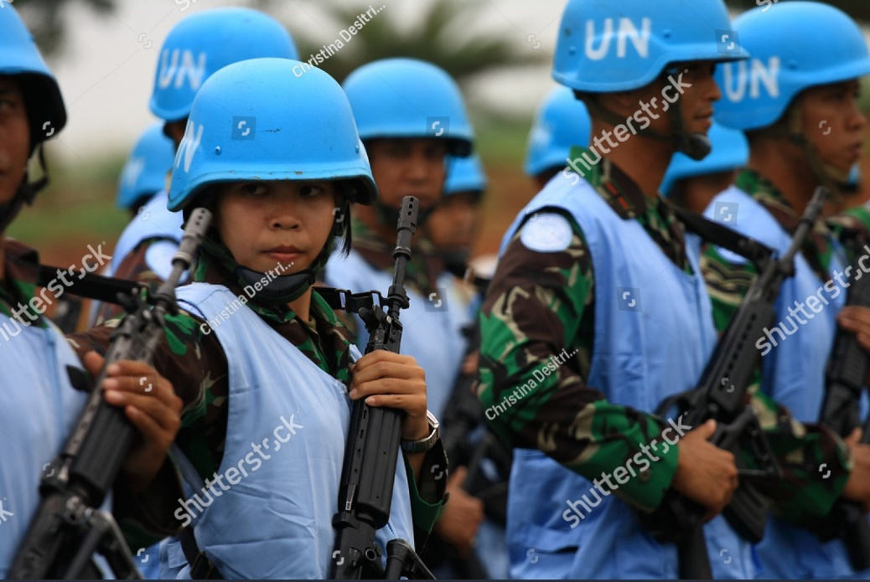
Tq-image-middle
URL | 1488814775 / Christina Desitriviantie / shutterstock.com

People everywhere need to be free of fear from all forms of violence and feel safe as they go about their lives, whatever their ethnicity, faith or sexual orientation. Conflict, insecurity, weak institutions and limited access to justice remain threats to sustainable development. In 2019, the number of people fleeing war, persecution and conflict exceeded 79.5 million, the highest recorded level.

Facts
Birth registration has occurred for 73 per cent of children under 5, but only 46per cent of Sub-Saharan Africa have had their births registered.
The proportion of prisoners held in detention without sentencing has remained almost constant in the last decade, at 31per cent of all prisoners.
In 2019, the United Nations tracked 357 killings and 30 enforced disappearances of human rights defenders, journalists and trade unionists in 47 countries.
Every 7 minutes, somewhere in the world, a child is killed by violence

Tq-panel-weblink
Goal 16: Promote peaceful and inclusive societies for sustainable development, provide access to justice for all and build effective, accountable and inclusive institutions at all levels

Targets
16.1
Significantly reduce all forms of violence and related death rates everywhere.
16.2
End abuse, exploitation, trafficking and all forms of violence against and torture of children.
16.3
Promote the rule of law at the national and international levels and ensure equal access to justice for all.
16.4
By 2030, significantly reduce illicit financial and arms flows, strengthen the recovery and return of stolen assets and combat all forms of organised crime.
16.5
Substantially reduce corruption and bribery in all their forms.
16.6
Develop effective, accountable and transparent institutions at all levels.
16.7
Ensure responsive, inclusive, participatory and representative decision-making at all levels.
16.8
Broaden and strengthen the participation of developing countries in the institutions of global governance.
16.9
By 2030, provide legal identity for all, including birth registration.
16.10
Ensure public access to information and protect fundamental freedoms following national legislation and international agreements.
16.A
Strengthen relevant national institutions, including through international cooperation, to build capacity at all levels, particularly in developing countries, to prevent violence and combat terrorism and crime.
16.B
Promote and enforce non-discriminatory laws and policies for sustainable development.

Goal 17: Partnerships
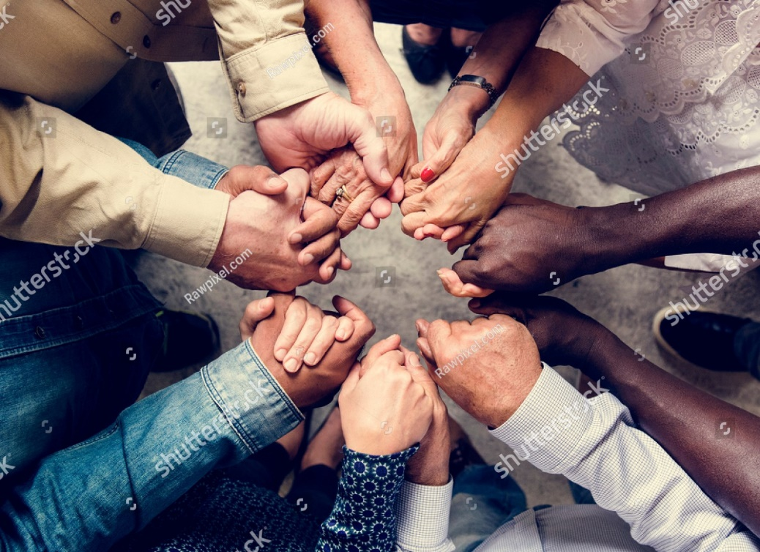
Tq-image-middle
URL | 1074714476 / Rawpixel / shutterstock.com

We are all in this together. The 2030 Agenda, with its 17 global goals, is universal and calls for action by all countries, both developed countries and developing countries, to ensure no
one is left behind. In light of the consequences of the global COVID-19 pandemic, strengthening multilateralism and international partnerships are more important than ever to solve the world’s problems. The global goals remain the framework for building back better, and governments, civil society, scientists, academia, and the private sector need to work together.

Facts
Official Development Assistance from OECD countries totalled $147.4 billion in 2019.
Seventy-nine per cent of imports from developing countries enter developed countries duty-free.
The debt burden on developing countries remains stable at about 3 per cent of export revenue
Almost half of the world’s population is not connected to the internet, particularly in developing countries.

Tq-panel-weblink
Goal 17: Strengthen the means of implementation and revitalise the Global Partnership for Sustainable Development

Targets

Finance
17.1
Strengthen domestic resource mobilisation, including international support to developing countries, to improve domestic capacity for tax and other revenue collection.
17.2
Developed countries to implement fully their official development assistance commitments, including the commitment by many developed countries to achieve the target of 0.7 per cent of ODA/GNI to developing countries and 0.15 to 0.20 per cent of ODA/GNI to least developed countries ODA providers are encouraged to consider setting a target to provide at least 0.20 per cent of ODA/GNI to least developed countries.
17.3
Mobilise additional financial resources for developing countries from multiple sources.
17.4
Assist developing countries in attaining long-term debt sustainability through coordinated policies to foster debt financing, debt relief and debt restructuring, as appropriate, and address the external debt of highly indebted developing countries to reduce debt distress.
17.5
Adopt and implement investment promotion regimes for least developed countries.

Technology
17.6
Enhance North-South, South-South and triangular regional and international cooperation on and access to science, technology, and innovation and enhance knowledge sharing on mutually agreed terms, including improved coordination among existing mechanisms, particularly at the United Nations level through a global technology facilitation mechanism.
17.7
Promote the development, transfer, dissemination and diffusion of environmentally sound technologies to developing countries on favourable terms, including on concessional and preferential terms, as mutually agreed.
17.8
Fully operationalise the technology bank and science, technology and innovation capacity-building mechanism for least developed countries by 2017 and enhance the use of enabling technology, mainly information and communications technology.

Capacity building
17.9
Enhance international support for implementing effective and targeted capacity-building in developing countries to support national plans to implement sustainable development goals, including through North-South, South-South and triangular cooperation.

Trade
17.10
Promote a universal, rules-based, open, non-discriminatory and equitable multilateral trading system under the World Trade Organization, including the conclusion of negotiations under its Doha Development Agenda.
17.11
Significantly increase the exports of developing countries, mainly double the least developed countries’ share of global exports by 2020.
17.12
Realise timely implementation of duty-free and quota-free market access on a lasting basis for all least developed countries, consistent with World Trade Organization decisions, including ensuring that preferential rules of origin applicable to imports from least developed countries are transparent and straightforward contribute to facilitating market access.

Systemic issues

Policy and institutional coherence
17.13
Enhance global macroeconomic stability, including through policy coordination and policy coherence.
17.14
Enhance policy coherence for sustainable development.
17.15
Respect each country’s policy space and leadership to establish and implement policies for poverty eradication and sustainable development.

Multi-stakeholder partnerships
17.16
Enhance the global partnership for sustainable development, complemented by multi-stakeholder partnerships that mobilise and share knowledge, expertise, technology and financial resources to support the achievement of the sustainable development goals in all countries, particularly developing countries.
17.17
Encourage and promote effective public, public-private and civil society partnerships, building on partnerships' experience and resourcing strategies.

Data, monitoring and accountability
17.18
By 2020, enhance capacity-building support to developing countries, including for least developed countries and small island developing States, to increase significantly the availability of high-quality, timely and reliable data disaggregated by income, gender, age, race, ethnicity, migratory status, disability, geographic location and other characteristics relevant in national contexts.
17.19
By 2030, build on existing initiatives to develop measurements of progress on sustainable development that complement the gross domestic product and support statistical capacity-building in developing countries.

Summary
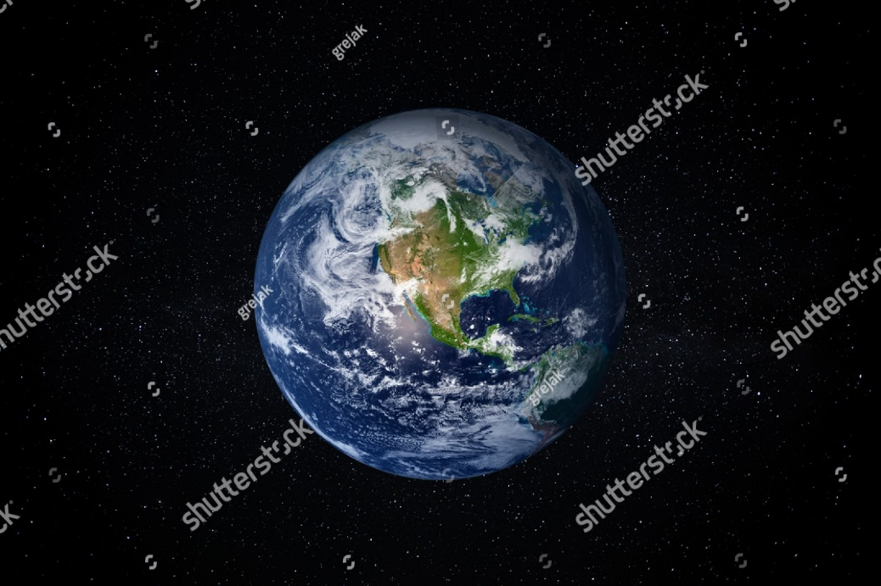
Tq-image-middle
URL | 1666159696 / 24K-Production / shutterstock.com

The Transforming, Our World Resolution neatly sums up the potential of the 2030 Agenda and the global goals: ‘If we realise our ambitions across the full extent of the Agenda, the lives of all will be profoundly improved, and our world will be transformed for the better.’
United Nations. Transforming Our World – The 2030 Agenda for Sustainable Development https://sustainabledevelopment.un.org/content/documents/21252030 Agenda for Sustainable Development web.pdf

In this module, we started on a journey to explore the 17 United Nations global goals and 169 targets and their links to the Millennium Development Goals. After delving into the facts and targets of the global goals, we also dived briefly into the indicators supporting some of the targets for Sustainable Development Goals (SDG) 4 because of their relevance to Queensland TAFE. You now know what each goal is aiming to achieve by 2030.
The United Nations Secretary-General Ban-Ki Moon provided clear guidance to the world on how we should act as individuals to make the planet a better place for ourselves and our children. He stated: ‘Be a global citizen. Act with passion and compassion. Help us make this world safer and more sustainable today and for the generations that will follow us. That is our moral responsibility.’
United Nations. https://www.un.org/sg/en/content/sg/statement/2015-05-27/secretary-generals-remarks-our-world-our-dignity-our-planet-post
Tq-panel-video
- The global goals we've made progress on -- and the ones we haven't | Michael Green (14:11)

References

United Nations. Millennium Declaration – 19 September 2000. https://undocs.org/A/RES/55/2
United Nations. The Millennium Development Goals Report 2015 https://www.un.org/millenniumgoals/2015_Millennium Development Goals (MDG)_Report/pdf/MDG 2015 rev (July 1).pdf
United Nations. The Millennium Development Goals Report 2015 https://www.un.org/millenniumgoals/2015_MDG_Report/pdf/MDG 2015 rev (July 1).pdf
United Nations. Transforming Our World – The 2030 Agenda for Sustainable Development https://sustainabledevelopment.un.org/content/documents/21252030 Agenda for Sustainable Development web.pdf
United Nations. Transforming Our World – The 2030 Agenda for Sustainable Development https://sustainabledevelopment.un.org/content/documents/21252030 Agenda for Sustainable Development web.pdf
United Nations. Transforming Our World – The 2030 Agenda for Sustainable Development https://sustainabledevelopment.un.org/content/documents/21252030 Agenda for Sustainable Development web.pdf
United Nations. Transforming Our World – The 2030 Agenda for Sustainable Development https://sustainabledevelopment.un.org/content/documents/21252030 Agenda for Sustainable Development web.pdf
Microsoft Educator Center. Teaching Sustainable Development Goals https://education.microsoft.com/en-us/course/72e17f8e/7
United Nations. Global indicator framework for the Sustainable Development Goals and targets of the 2030 Agenda for Sustainable Development. https://unstats.un.org/sdgs/indicators/Global%20Indicator%20Framework%20after%202021%20refinement_Eng.pdf
United Nations. Transforming Our World – The 2030 Agenda for Sustainable Development https://sustainabledevelopment.un.org/content/documents/21252030 Agenda for Sustainable Development web.pdf
United Nations. https://www.un.org/sg/en/content/sg/statement/2015-05-27/secretary-generals-remarks-our-world-our-dignity-our-planet-post

